Colorado State University
The Classical Front
The influence of Palladianism on the building of Fort Collins High School, 1400 Remington Street
Kaitlyn Birdsall
10/11/2009

A building façade can convey many different messages, including its purpose and stature in a particular community. It freezes a moment in time and must be viewed through a historical lens. Its source for inspiration is embedded in its walls. A building tells of a story of a community, of the lives that have passed through it, and of the changing landscape around it, showing its age through the ornamentation and telltale signs of wear. Such is the case for the building located at 1400 Remington Street. Once the cherished new building to house Fort Collins High School, its purpose and its structure have changed only recently to become Colorado State University’s University Center for the Arts. Yet this structure is much more than a building: it is an icon for the town of Fort Collins, a building that was not spared any effort or expense in order to make a beautiful and functional architectural work of art.
While many look at the columned façade and understand its derivation from the Classical style, there is a much more profound story regarding the inspiration and historical events that lead to that particular style arriving in Fort Collins, Colorado. In fact, the style can be traced back to a Renaissance architect named Andrea Palladio, whose architectural treatise revolutionized the architecture of Europe for centuries, even spreading as far as the United States through Thomas Jefferson and other such architects. However, it was not only the architectural style that transferred overseas and through the centuries. There is an ideal and moral standard that was carried along with it: the belief that the Classical Cultures or cultures of Antiquity were morally, politically and socially just and thus studying the “classics” would form an adequately educated person –thus a building could represent rational proportion, dignity, and Democracy, which directs a person to the moral, antiquarian, and correct way of life. Fort Collins High School exhibits Palladian elements, and by incorporating the Palladian style, the building also contains the hidden meaning of Palladian humanist values of classicism. To follow the development of the inspiration of the Fort Collins High School, this paper will discuss the historical development of the style, how this building can be categorized with this particular style, and how the renovations have changed the building.

The Development of the Palladian Style
To understand the complexities of the hidden meaning of the architecture through the display of style, an understanding of how this style came to be must be covered. This particular style has had several stages in time when it was more influential, and went through several developmental changes. To follow it from the beginning, one can trace it from the original architect of the 16th century, Andrea Palladio. The burst in Palladian architecture in England began with Inigo Jones as the Royal Surveyor, and was brought overseas by the U.S third president, Thomas Jefferson. It has undergone transformations through several revival movements to arrive in the 20th century.
Andrea Palladio was one of the first architects to combine the classical Roman architecture with a strict mathematical proportion formula, which had an astounding affect on later architecture for centuries to come. Born in 1508 near Venice, he was apprenticed as a stone carver, but these humble beginnings changed when the Humanist Gian Gorgio Trissino took him under his wing, encouraging and funding his studies in the classics and his study of classical architecture in Rome. In fact, Trissino was the one to give him the classical name Palladio, changing him irrevocably from the mere stonemason Pietro della Gondola. Under his guidance, he studied the treatise of Vitruvius and Serlio, and became firmly founded in the classical ways, believing that, “the study of ancient remains is a path to the power and moral force of the ancient Romans.” As he studied the classics, Palladio developed his theory that Cultures of Antiquity had perfect mathematical proportions relating the orders of columns to the size and style of the architectural building. This specific classical proportion for each order of columns along with other theories on the proper antiquarian approach to architecture were written by him in a treatise, published in 1570, called I Quattro Libri dell’ Architettura. His architectural style was defined by its symmetry, with the middle entranceways being the axis on which he based the plan on. He was the first to begin using the temple front with columned porticos with pediments for villas which became his most imitated device, using the columns to base the proportions of the rest of the building. (FIG 1) Palladio used the proportions of antiquity to create a style that would capture the dignity and glory of the ancients, making it so that the rational classical style symbolized importance and good taste. Art Historian Rudolf Wittkower described Palladio’s style as, “ (taking) his inspiration from traditional architecture, but his genius, reinforced by classical studies, gave an unexpected quality to these traditional elements, creating a new architectural system....” His firm basis on the Humanist Classical studies was carried on with his style into England during the late 16th century and beyond.
In the late sixteenth century, England also used the Palladian style to not only represent the dignity of the classical cultures, but eventually it came to represent the politics of Antiquity as well. England adopted Palladian neoclassical style under the supervision of Inigo Jones, who lived from 1573 to 1652. It became the standard for English Country Houses in that Palladio’s designs were imitated, were the inspiration, or somehow had an influence in nearly all building projects during this time. Inigo Jones and other contributors, such as Lord Burlington, transformed English countryside from the mostly Gothic style to the classical temple style as the only acceptable architectural style. This encouragement of the Classical style had political ties as well, due to England being in political turmoil during most of this time. The idea of Greco/Roman style houses reflected a model government, for it represented the first democracy, and its emphasis on proportion and rationality. This rational style was associated with the Whig party and their desire to give England its own national architecture unconnected to the Baroque of the Pope and absolute monarchy. The austere Palladian architecture lent itself to the Liberal Whigs because of its association with the democracy of Antiquity, which also allowed for the style to transfer to the new Democratic Nation of the United States.
The United States provided new soil and new theories to add to the ideal Classical Palladianism. It was through the US third president Thomas Jefferson and his well known home, Monticello ( FIG.2) that the name Palladio become commonplace for those considered cultured. His first building, the Virginia State Capitol at Richmond ( FIG 3) , finished in 1792, borrowed many ideas from Palladio, using a temple style based on the French Roman temple of Augustus, Maison Carrèe, and keeping with Palladian formula for column proportioning. Monticello, built between 1796 and 1809, was his home in Charlottesville, Virginia where he exercised an even more Palladian style, using an octagonal planned axial center that is emphasized by the third story dome and a columned temple portico. Jefferson was along the same lines of thought as Palladio, believing the orders and classical studies to be of utmost importance, and looked down upon the architects that were “’scarcely…capable of drawing an order.’” Jefferson identified with Palladio’s Humanist belief, believing like Palladio that, “Ancient architecture gives us a certain idea of Roman virtue and greatness.” He wanted to incorporate a style that would give the United States glory in the eyes of the rest of the world, and considered, like Palladio, that Roman buildings were “the constant measure of permanent values”. The Palladian style continued to grow, having been incorporated into American architecture after Jefferson. The Neo-Classical Revival of the mid 1880’s had a similar draw to Palladianism, although on a much larger scale. Usually those buildings were built for the purpose of exhibitions, museums and other academia, using the temple front like Palladio. Unlike Jefferson, it relied more heavily on the Greek orders as opposed to the Roman, but it provided a renewed interest in Classical style structures. ( FIG. 4)
With the growth of Palladianism and its Humanist roots, it can easily be applied to an academic structure. This influential style travelled through the ages, gaining more contextual meaning during each time it was used, but continuing its firm foundation of classical equaling Antiquarian value and dignity as well as academia. It can thus be understood how such a style came to be on the façade of a high school building built in 1924. But the question is if it truly can be traced to these roots, what did the FCHS building obtain from Palladianism in both architectural form and philosophical tendencies?
Academic Influences
Palladio influenced great buildings of political purpose, or personalized country houses. In England and early America, this style displayed power, importance and wealth. Yet, this style came to be found on the front of many public schools. It is very understandable in consideration with its Humanitarian roots and the desire to display a place of learning as founded on these classical ideals. American schools in the mid nineteenth century moved away from the single room schoolhouses to building of greater value and importance. This was because of many of the academic theories of the day often had architectural treatise tied to it. One of these architectural school leaders was Henry Bernard(1848), who said “Every school house should be a temple, consecrated in prayer to the physical, intellectual, and moral culture of every child in the community, and be associated in every heart with the earliest and strongest impressions of truth, justice, patriotism, and religion.” This points directly towards the same beliefs that both Palladio and Jefferson were firmly founded on, but now it was applied to schooling. Also note the use of the term ‘temple,’ which can be taken as a reference to the temple fronts that began appearing on many school structures during this time, including Bernard’s own designs of Greek Revival Schools.
The feeling that nothing should be spared in order to create an environment amenable to learning affects school buildings to this day. John J Donovan, the writer of a school architecture treatise of the same year as the building of FCHS, believed that high schools “ should impress upon the student the value of dignity, proportion, and good taste.” This idea is tied with Palladian roots, for these were the same values he placed on the Classical style. The influence of classical architecture on schools meant that the school could appear respectable and dignified, just as Jefferson incorporated Palladianism to dignify the New Country. It also reflected what was being taught inside –classical academics such as reading, writing and arithmetic, which have been taught to educated people since ancient times. Palladio’s teacher Trissino passed the importance of classical academics on to his pupil. Thus a school using the Palladian style of Proportioning to display the dignity and importance demanded by a classical style building can also represent the desire for the inner academia to demand rationality, democracy and dignity.

Defining 1400 Remington as a Palladian Structure
There were many buildings with different purposes being built during the 1920s, but the increase in funding going towards school building displayed a change in attitude for American culture to give its children a bright future founded on academia. While many styles were used to in designing school buildings, Classical roots are obvious when looking at the architecture of Fort Collins High School. Its cornerstone was laid on May 9th, 1924, with a speech by Superintendent Dunn describing the buildings purpose and foundations. He began his speech comparing the great monuments of every culture, but indicating how none had the purpose of teaching their children, while America put its, “school as the highest expression of our progress for today and our fondest hopes for tomorrow.” He also ended his speech saying, “And in that faith we lay this cornerstone today, believing that we are thus laying a strong and deep the adequate foundation of enduring democracy.” Throughout his speech, there is an underlying theme of classical foundations. The building was built with the purpose to teach the classics, just like Palladio’s teacher Trissino taught Palladio the Humanities of classical academia. Dunn’s mention of the democracy and building model citizen, connects it to the first democracy, just like Jefferson attempted to do with his own architecture as he built the foundations of a democratic nation. The actual building of Fort Collins High School cost $330,000, and its Architect was William N. Bowman of Denver. The final part of the building, the tower which has come to represent all of Fort Collins and symbolized the end of the building time, was raised on November 12, 1924. The building was very symmetrical in plan while not sacrificing its functionality to be so, and it was based on an axial plan with an entrance suggesting importance through the use of a temple portico. Some of its architectural stylistic integrity was altered with additions, such as a new athletic complex on the North side in 1953, however it maintains its front façade to this day. To fully understand the complexities of the influences on this building, a study of the different elements and their relation to the Palladian or Jeffersonian style must be made, as well as an understanding of the importance of School Architecture and its methodology during this time.
There are many aspects of the old Fort Collins High School building, located at 1400 Remington Street, that can be connected to Palladian roots. While it cannot be of the same quality of materials and manpower as many buildings of Antiquity, considering its limitation for cost, time, and function, there are still many elements that have derived from classicism. The original plan of the building is in fact Palladian, with a central entrance and two symmetrical wings. Palladio’s most well known buildings have central plans. This plan with a central entryway and two symmetrical flanking wings can also be seen in his villas Barbaro and Emo.(FIG. 5) This plan was repeated in work in England, such as William Kent’s Holkham Hall in Norfold, built in 1734 to 1765.( FIG 6). Relations and Proportion was the most important aspect of Palladio’s theories, who believed that the orders of columns had to relate to the entire building.
Another important aspect of Palladio’s architecture was the triadic proportioning, where usually three levels were involved with hierarchical importance, and each part relating to another and to the building as a whole. The Fort Collins High School building has three different levels, but it does not completely adhere to Palladian ideals in regards to the hierarchical value. Palladio believed the middle floor should maintain the most importance with a sophisticated stair entrance to it, while the lower level should be that of a rusticated basement fit more for lower class. The building at 1400 Remington does maintain the impressive stairway, with the entryway on the lowest level. This can be debated, with the mid-stair level and its openness to the windows (FIG 7) seeming to put an emphasis at that particular place, yet there is no distinct sizeable difference between the different levels in terms of height, which in Palladian terms would equal importance. Still, its triadic levels maintain the remnants of Palladian themes.
Relations and proportion was the most important aspect of Palladio’s theories, who believed that the orders of columns had to relate to the entire building. The façade of FCHS has eight tall pillars of the Tuscan order (Fig 8), each being equally spaced except for the emphasis on the entryway, which is slightly larger to allow for the doorway. The Tuscan Doric order was considered by Serlio to be primitive and manly, but it was used in Palladio’s first structure, the town hall called the Basilica in Vicenza, where he used engaged Ionic Orders with a Tuscan Doric floor. Through his emphasis on proportioning and the order of columns, Palladio wanted to display the Humanist belief that, “the supreme and logical Order that permeates all of God’s creation should be ‘imitated’ in the creations of men.” The Tuscan order relates better to the rest of the building because of its unfluted shaft and plane base, with the simple entablature becoming a repeated form throughout the exterior of the building. These particular columns appear to follow the proportions set up by Palladio where the height relates to the diameter as well as remaining relational to the building itself. The Tuscan Order has been used in several important buildings in the United States as well, including Jefferson’s Monticello ( refer to previous fig. 2). Perhaps the importance of using the Tuscan order has gained its inspiration from Monticello, where Jefferson was attempting to make a strong foundation and establish that America was just as important as the rest of the world and deserved respect for its foundations in classicism. This school was attempting to create a firm foundation for the children that would go through it, and establishing its worth to the community by displaying its firm foundation in classical academia.
The rest of the façade certainly follows a Jeffersonian style –inspired by Palladio –and reestablishing the school building as the foundation of the United States, just as Jefferson initiated classical Palladianism into the U.S.. The triangular pediment remains rather plain, which relates once again to the Doric order and Palladian theories of how such elements should relate. Its single oculus window that has become oval in shape, with emphasized keystones, does not relate to the Jeffersonian structures, which normally put a fanlight in that position. It could take its influence from Palladio’s Rotunda (fig. 9) –However in that particular building, Palladio uses two oculus windows in opposite side of the triangular pediment instead of one. It also secedes from both styles by having the pediment filled with bricks as opposed to a continuation of the stone of the entablature and columns. Of course, if this had not been done, there would have been no way to highlight the keystones as does, which adds to Palladian ideas, for almost all Palladian structures emphasize the keystone, even on rectangular windows. The rest of the façade also has emphasized keystones on all of the rectangular windows, as well as the fanlights above the main windows. Which brings about another point: the triadic main windows, which are accentuated in importance, also have Palladian inspiration. Once again, look to Palladio’s first structure the Basilica (FIG 10), which take a continually repeated form of a main arch flanked by two small arches, which took its influence from Serlio(Fig. 11) initially. While this form has obviously been augmented and transformed through the years, the basic shape was originally from this Classical idea. The triadic windows with a fanlight above each of them can also be traced to Jeffersonian, for Monticello had them on the side of the house. In fact, even the red brick in combination with the white portico can be considered Jeffersonian. However, the sheer massiveness of the building in order to be functional as a school does not allow for the normal two (or single) levels of the wings of most Jeffersonian building.
It is once the viewer steps away from the façade that a somewhat unsuccessful Palladian style can be seen. This is in view of the upper story windows on both wings. The entablature continues from the façade onto the wings in order to create unity, which can be viewed with an idea of the rationality of Palladianism. However, Palladio would have been appalled by the fake balustrade (fig 12.) only applied to the roof section about the middle window. It appears out of place and awkward, and is not successful, but it is inspired by Palladio in the fact that this element is repeated on both wings, and the actual element is extremely Palladian. Balustrade was not an Antiquarian element, but was in fact created and became popular during Palladio’s time. While Palladio normally used type I ( Fig 13) for its symmetrical double bulbs, he still did use the single style balustrade, and it was definitely a prominent element in many buildings influenced by Palladio. Once again, a look at Monticello (Fig.2) shows the use of balustrades in American architecture. However, just simply using it in a decorative purpose to once again point to the architectural Palladian style is overly exaggerated: it makes it appear like the construction would be too expensive to do balustrades on the entire front, so a simple three feet on each side would do. This style just appears ungainly. Still, there is no denying its influence.
Continuing on with that section, there is a triangularly pedimented window just below the balustrade. It is reminiscent of the Palladian style buildings with pedimented windows ( Fig. 14). However, the architect decided to add ornamentation unnecessarily on the points of the triangle (FIG 12). Without that sort of decoration on the main portico, it seems awkward and does not relate well. However, it is a reference to Antiquity to possibly either an acorn decoration that generally sat at the top of buildings, or to an antefix, which is a vertical ornament at the top of cornices.
Another interesting element is the fake quoins (Fig 15) using a lighter colored brick to separate the corner from the rest of the building. However, it is not done on every corner, but deals one with certain corners of what appears to be no consequence –there is some at the end of the facade block, but no others on the front of the building, while the back of the building has one on almost every corner. Perhaps this is an issue of previous renovation, but it does appear purposeful in its sporadic decision. Even acknowledging its oddity, its inspiration must be attributed to English Palladianism.
“Historic Sensitivity with Contemporary flair”
The renovation and additions done in order to transform the old Fort Collins High School building into a state of the art University Center for music, performing arts, and dance of Colorado State University had a great impact on the stylistic view of the building. SLATERPAULL Architects worked several years in order to renovate the building into being useable as well as aesthetically pleasing. It is very obvious that the architectural planners studied the prior building with intensity, and many forms found in the older building are repeated in the new one. However, because of the functional, financial and historical limitation, a completely historically accurate addition could not be made. However, the architects were not necessarily wanting an addition that molded into the previous building. Their design concept, “Historic Sensitivity with Contemporary flair,” meant they wanted to use as much of the historic material as possible and not sacrifice its quality but still add a modern twist to the building. Jennifer Cordes of SLATERPAULL describes working with the old building as “working with the preexisting box.” However, the repeated motifs in the Griffin Concert Hall in particular, while imitating some of the Fort Collins building, lacks connection to Palladian rationalism.
The actual placement of the building does not relate to Palladian ideals of symmetry. Griffin Concert Hall, while being beautiful and wonderful for housing the music hall, throws off the symmetry of the preexisting building. However, this is not completely the fault of SLATERPAUL: a preexisting rendition had already changed the symmetrical layout of the building plan. However, the addition of the Griffin Hall further radically changed the layout of the building plan, from the original main axial block with two symmetrical wings into the north wing having a large frontal addition.
Where SLATERPAUL truly jumped into contemporary flair with the Palladian themes was the use of the pillars. Emphasizing the segmentation of each pillar, the capital of this Tuscan like rendition of a column has triangular shapes that seem to echo the pediment on the adjacent portico (fig. 16). The first entablature continues off the north wing of the building, which ended on the second floor, meaning it is much shorter than the FCHS portico. To add height, a second story of columns was added. So, while the first column ends at the lower entablature, the next two continue on and their capitals rest on a higher entablature; it is repeated on the other side(Fig 17). Both entablatures are flat with surface crenellation like decoration on the surface above each column, reminiscent of many Palladian inspired structures like Monticello. Yet it lacks a pediment; without the triangular form, the columns seem somewhat out of context. However, the double entablature with different levels could relate to the triadic windows of the FCHS portico, thus relate to Palladian themes. The columns do seem to have the proportional relations and space between each column contains a Palladian ratio. The columns have a repetitive form around the building, using a trio of columns set on a raised brick segment capped with the sandstone colored porch as well as the repeated entablature form with the indentations above each column. Between each column, there is a square decoration split into eight sections, reflecting an element in the main building, where the pediment wing window has the same split square window, although it lacks the middle bar and thus is only split into six parts( fig. 18). Even in the back of the building, engaged columns of a similar style are used only for decorative purposes. These columns and the proportions do connect to Palladianism, but many of the basic forms, and irregularities found in the building connect it more to being a contemporary building with references to the previous building and its Palladian influences. Thus, Palladio was not a direct influence. Still, its connection to the prior building with some stylistic changes reflects what has changed in the purpose of the building: this contemporary building with a classical twist is perfect to house a Center for the Arts.
Conclusion
The architecture of FCHS can be classified as having Palladian influences. This is not only in connection with the architectural proportioning, ornamentation, and symmetry, but also in regards to the Humanist ideals Palladio began with, firmly embedded in the belief that studying the ancients and following classical academia was the only way to become a sophisticated person. The front of the building is but a display of what is studied inside. However, the renovations done to the building, while successful in making a beautiful and functional building, have denied much of the Palladian influence of the main building. This contemporary twist of Palladianism can relate better to the new purpose and function the building has taken on. Palladio will continue to affect architecture for centuries, for any building attempting a classical style will have to understand Palladio’s proportioning of columns, or else the viewer shall see it as “wrong.” Palladio’s influence can be seen ever since his first building, and it makes sense that in the United States, where education is so highly valued, that classical ideals would be reiterated.

Illustrations
FIG. 1 – an example of Palladio’s use of a temple front on a villa: Villa Badoer, Polesine, 1554.
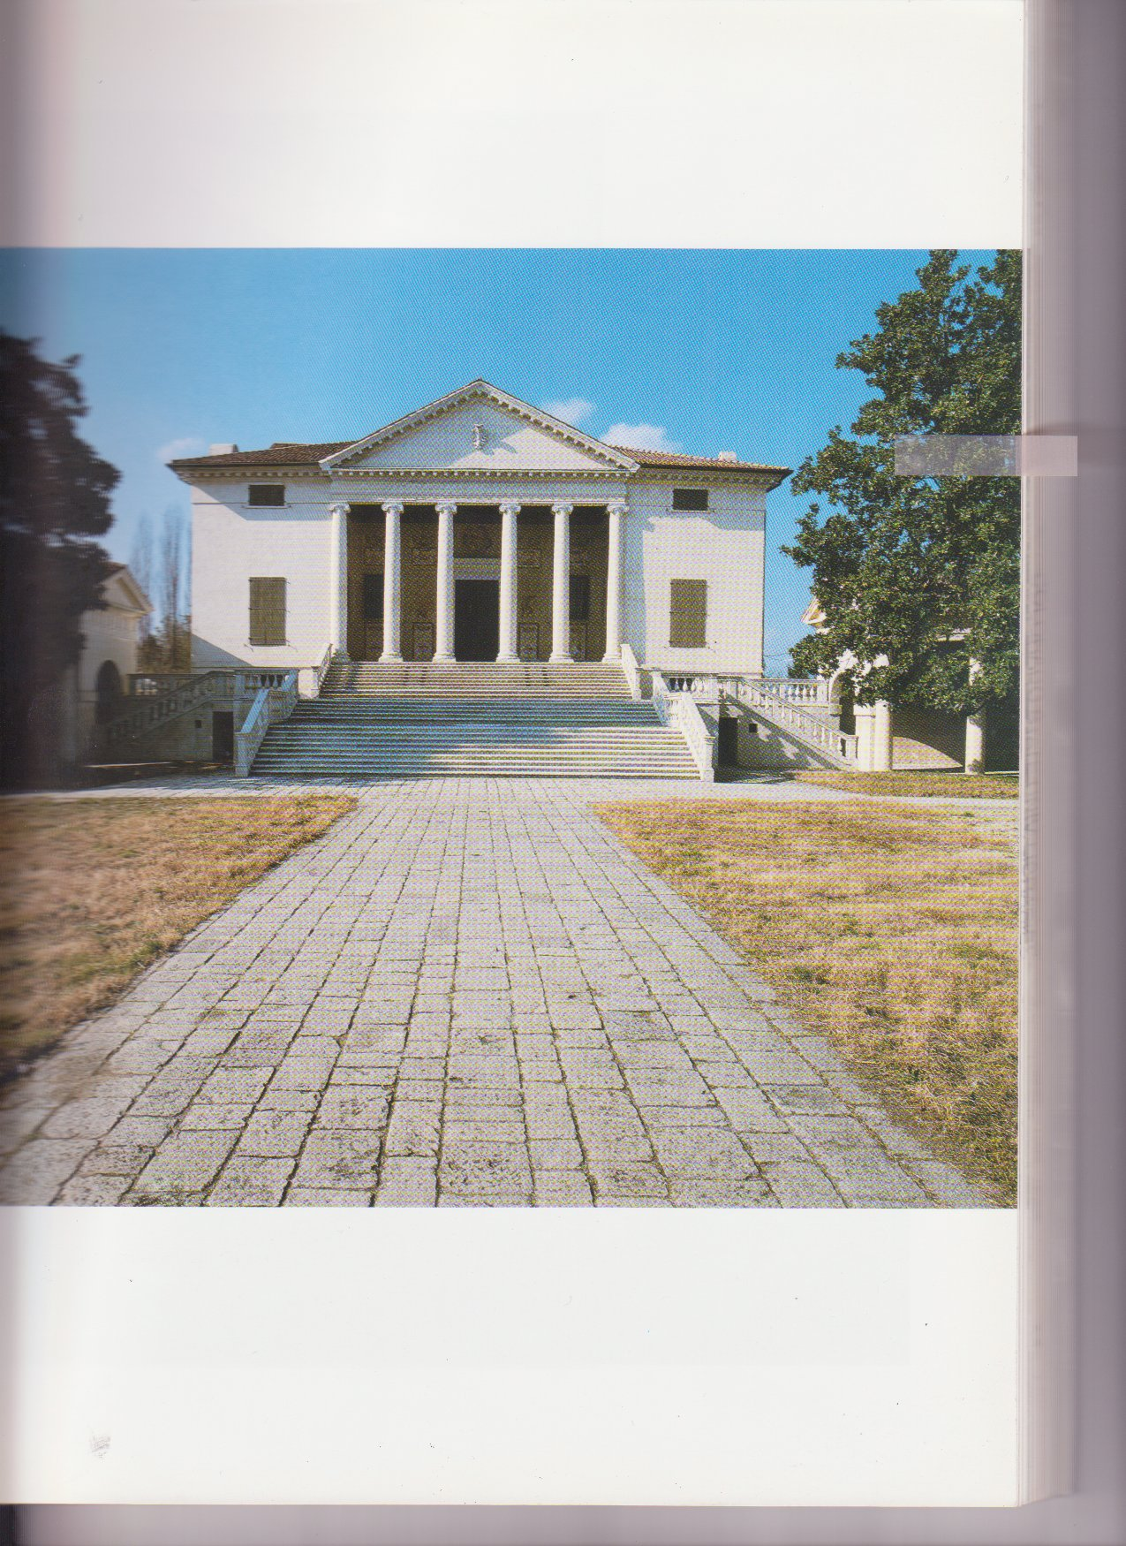

FIG. 2- Thomas Jefferson’s Home, Monticello in Charlottesville, Virginia
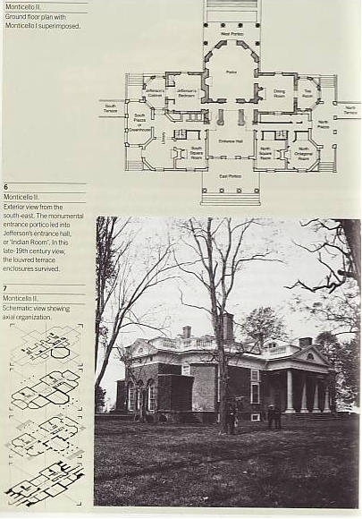
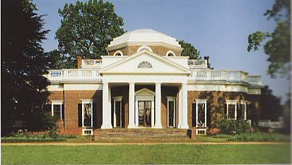

FIG. 3- Thomas Jefferson’s Virginia State Capitol in Richmond
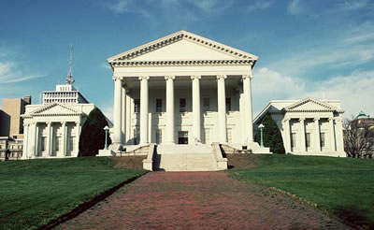

Fig. 4 – an example of Neo Classical architecture in the United States
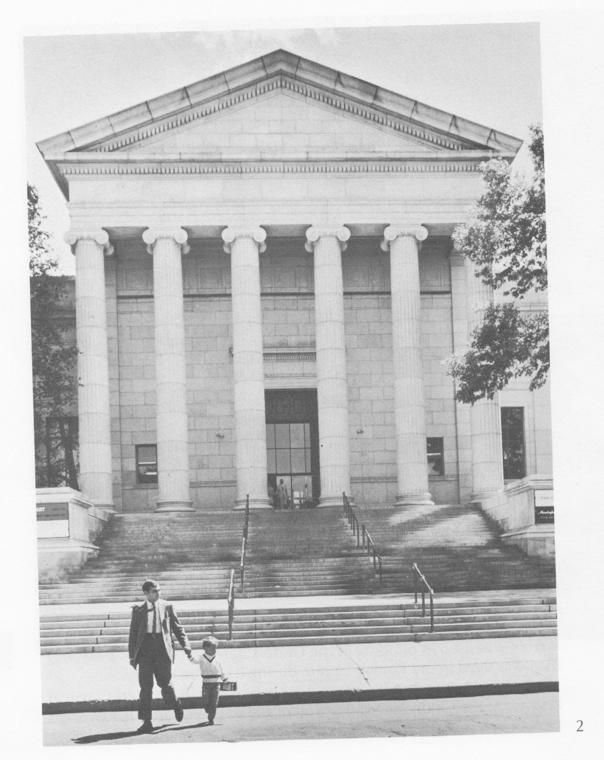
The Minneapolis Institute of Arts, Minneapolis, M Minnesota. McKim, Mead and White, architects, 1912

FIG. 5, Palladio’s Villa Barbaro and Villa Emo. Notice their central entryway with symmetrical flanking wings
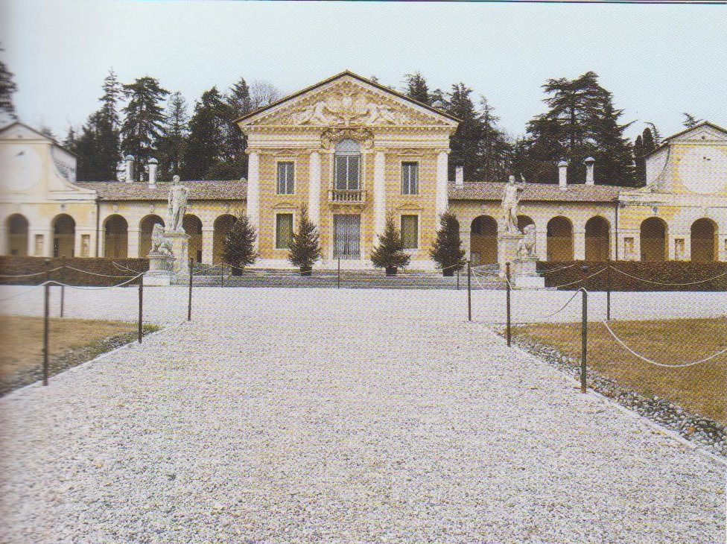
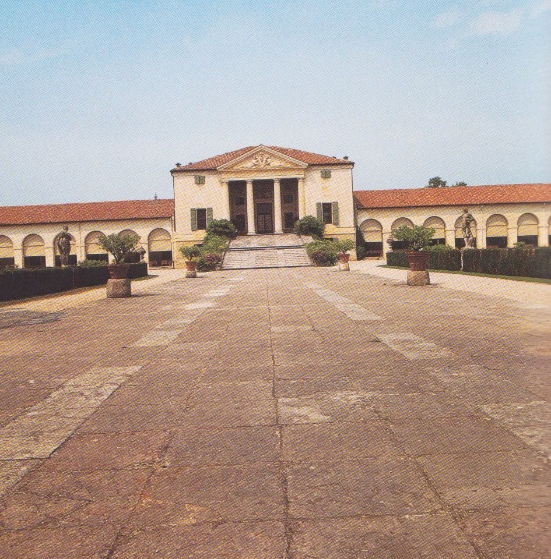

Fig 6, Kent’s Holkham Hall in Norfold, built in 1734 to 1765
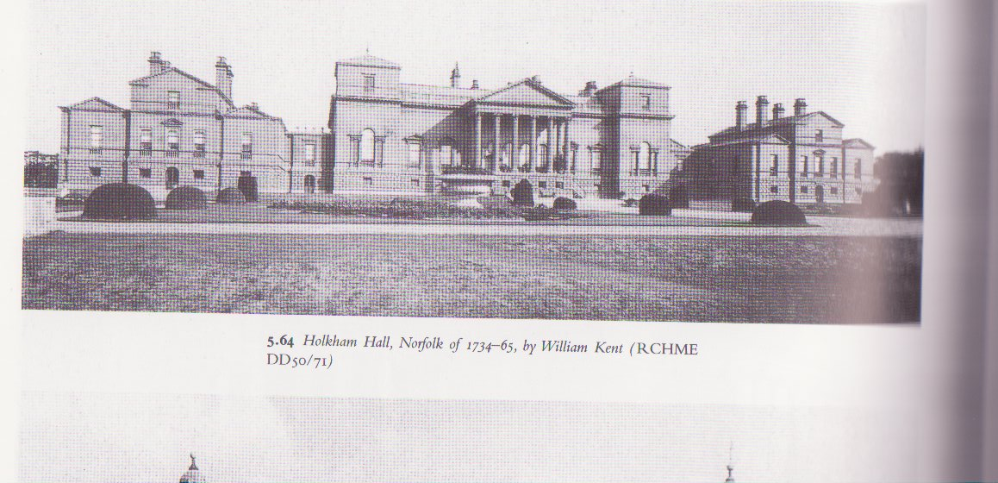

FIG. 7 Mid-stair landing in the FCHS building, post renovations
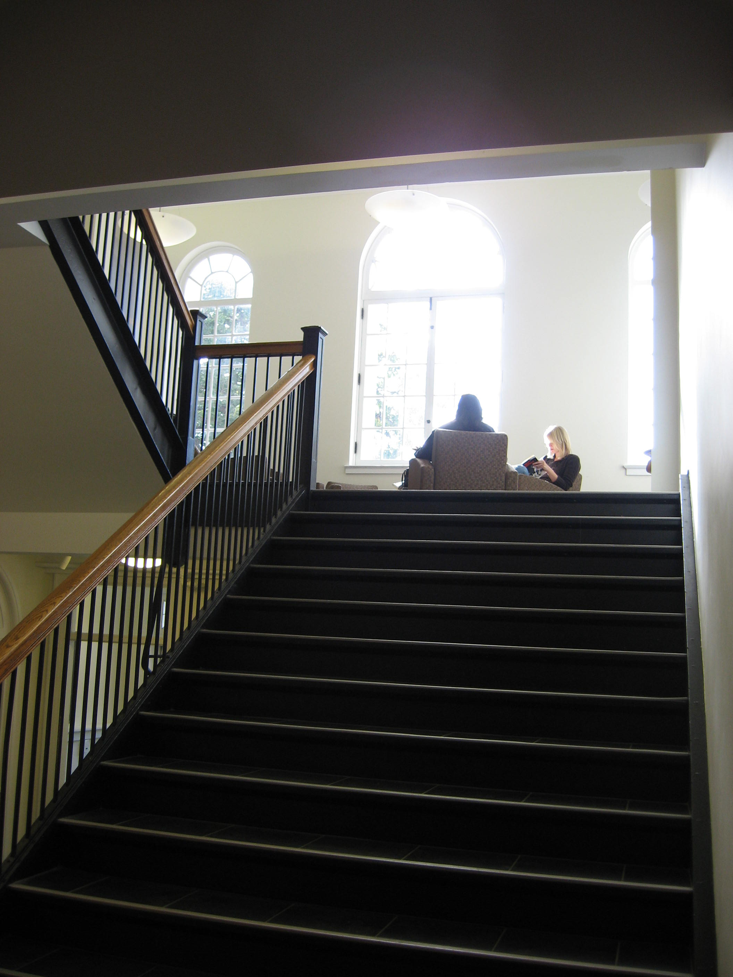

Fig 8, the façade of FCHS
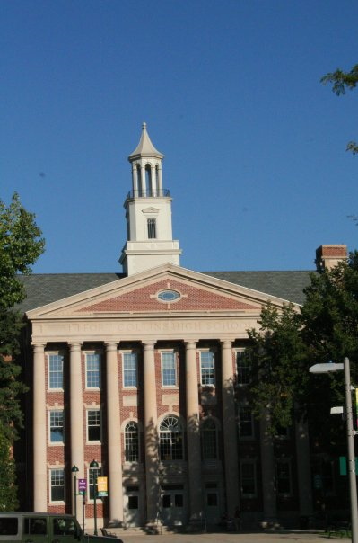

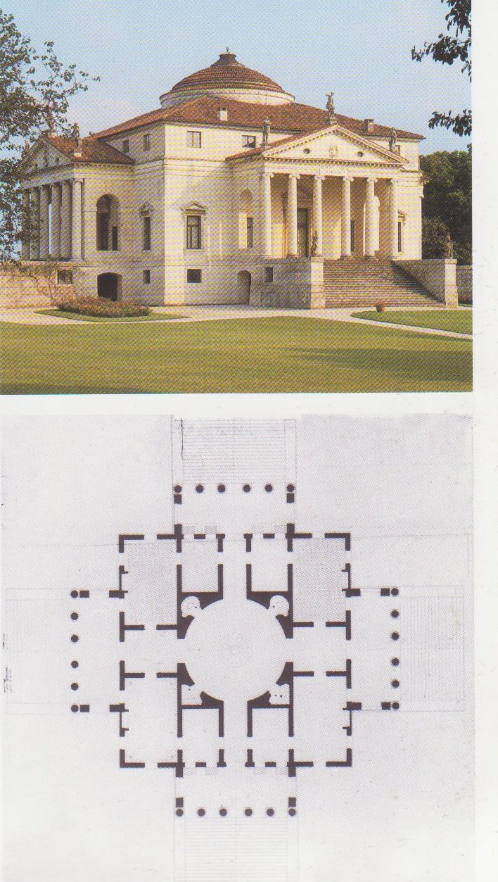

FIG. 8, Palladio’s Rotunda

Fig. 9, Palladio’s Basilica
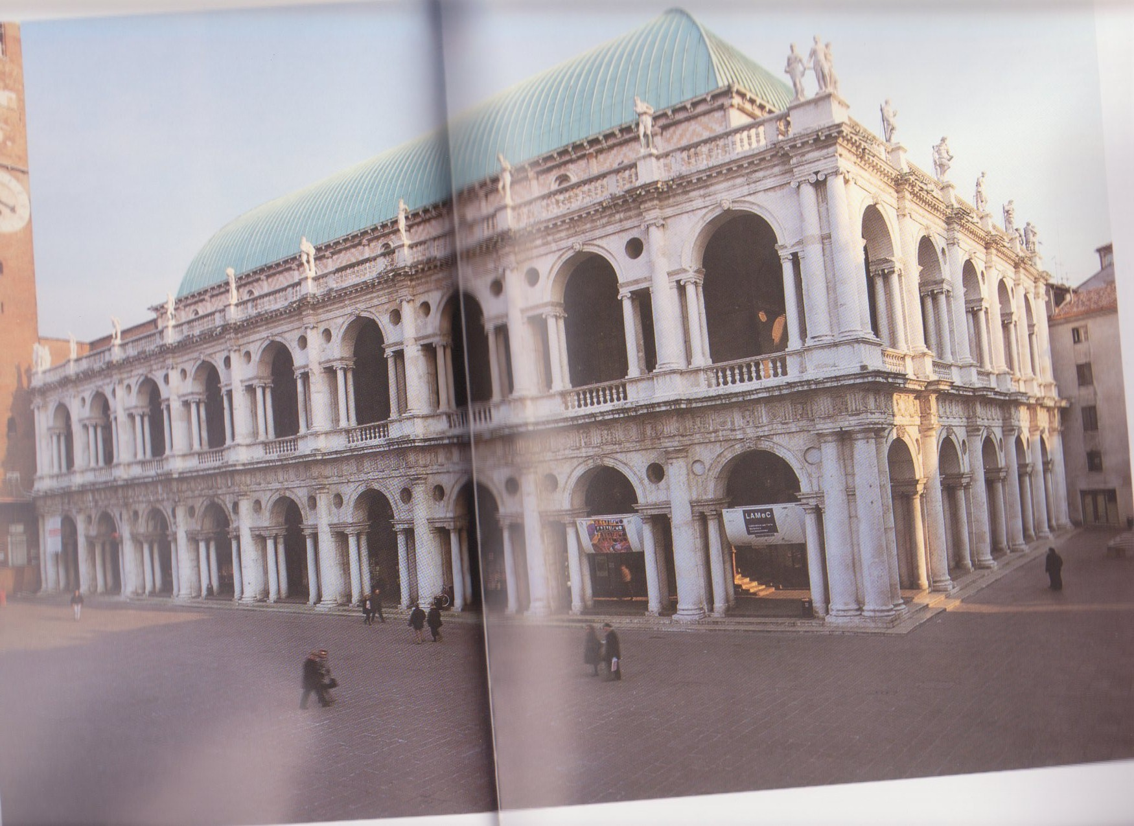

Fig. 10, Serlio’s design which inspired Palladio’s Basilica, called the serliana/ Venetian Window; Palladio used it in many designs, but he got this element from Serlio’s Architettura ( 1537-51)
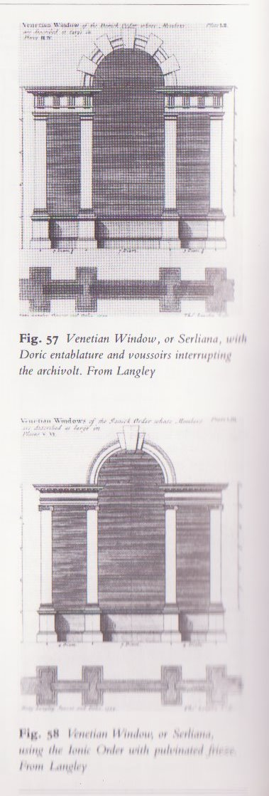

Fig. 11, wing ornamentation on FCHS – notice the false
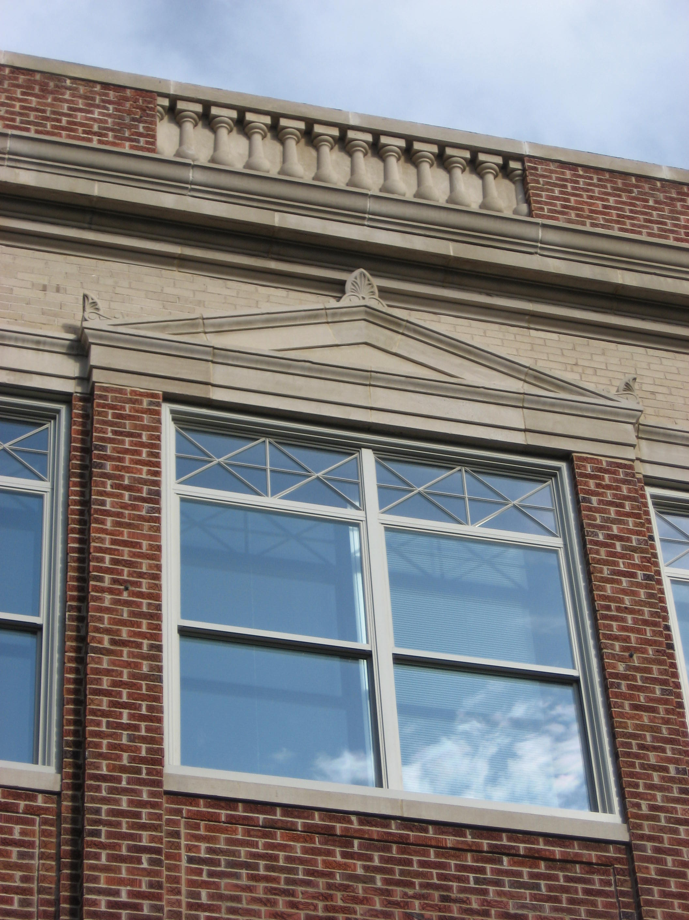
balustrade

Fig 12, Renaissance Balustrade’s
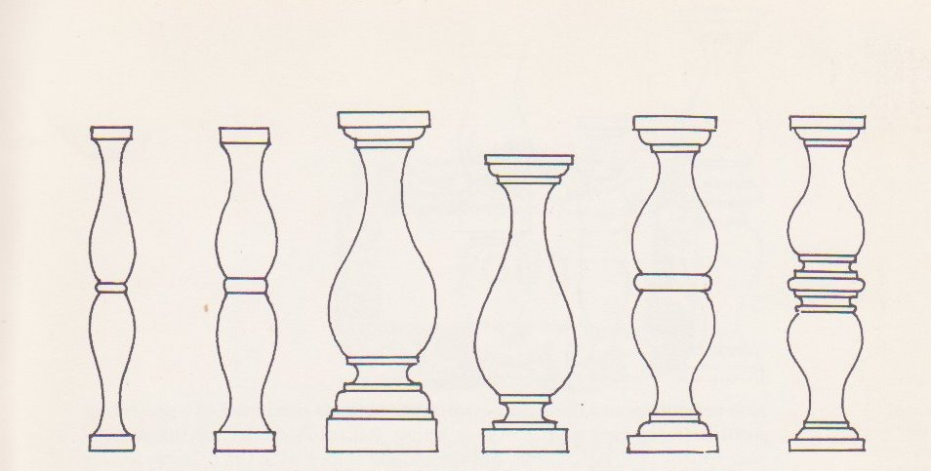

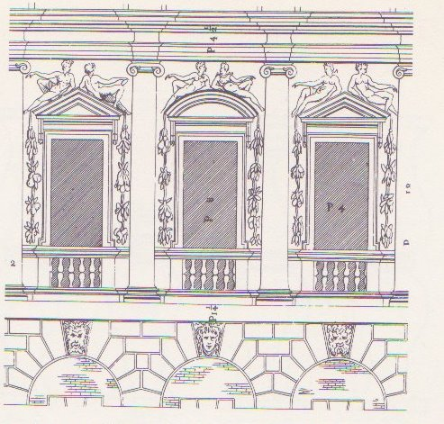

Fig 13- an example of Palladian pediment windows

Fig 14 Brick quoins on the FCHS building
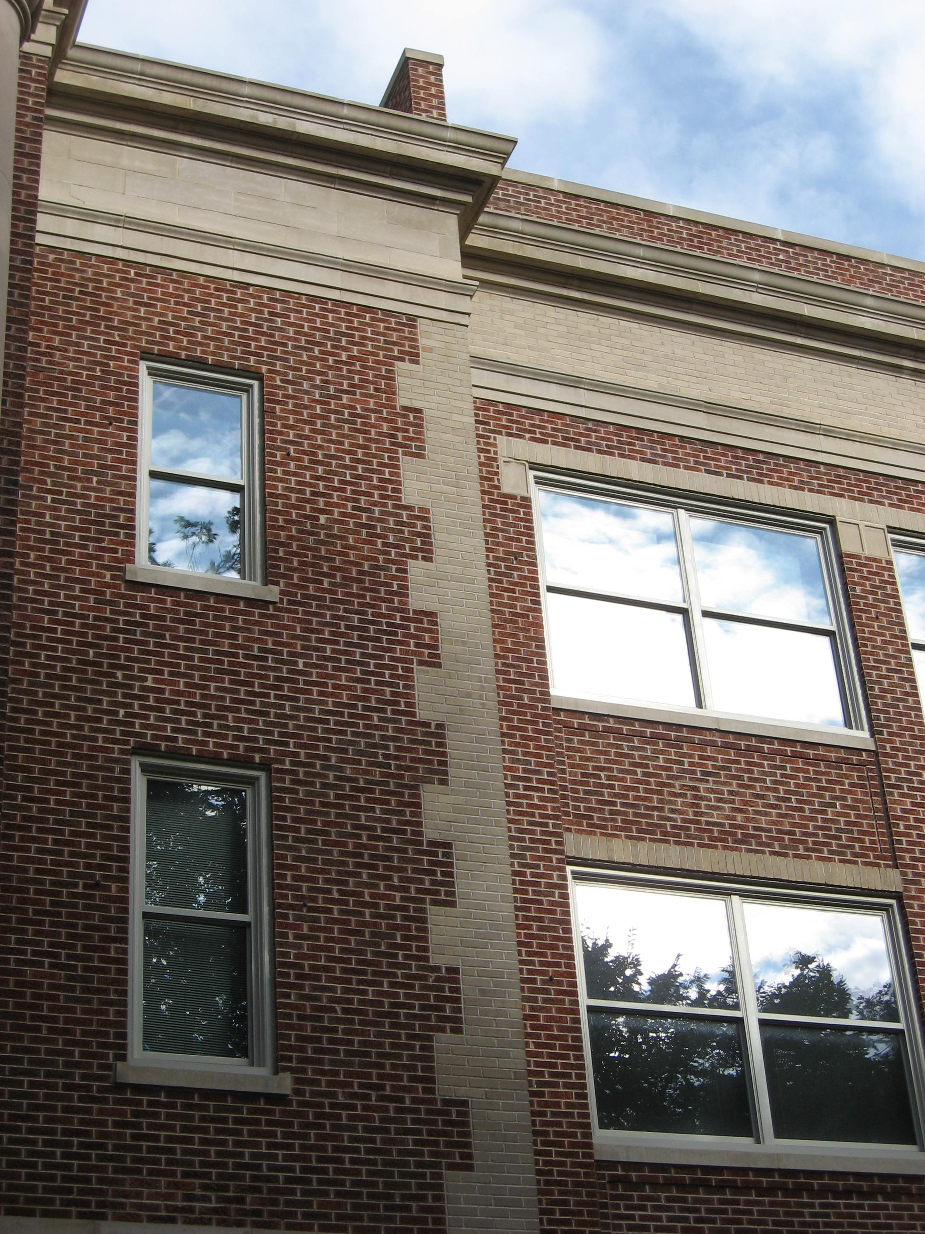

Fig 15, columns on the portico of the Griffin Concert Hall
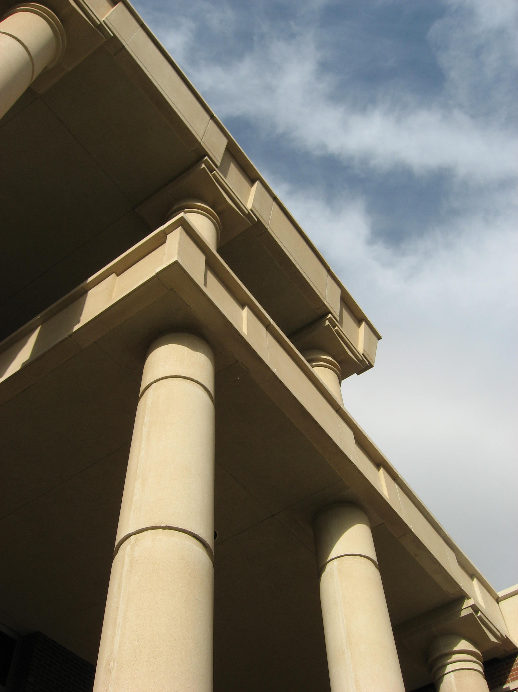

Fig. 16, The entryway to Griffin Concert Hall
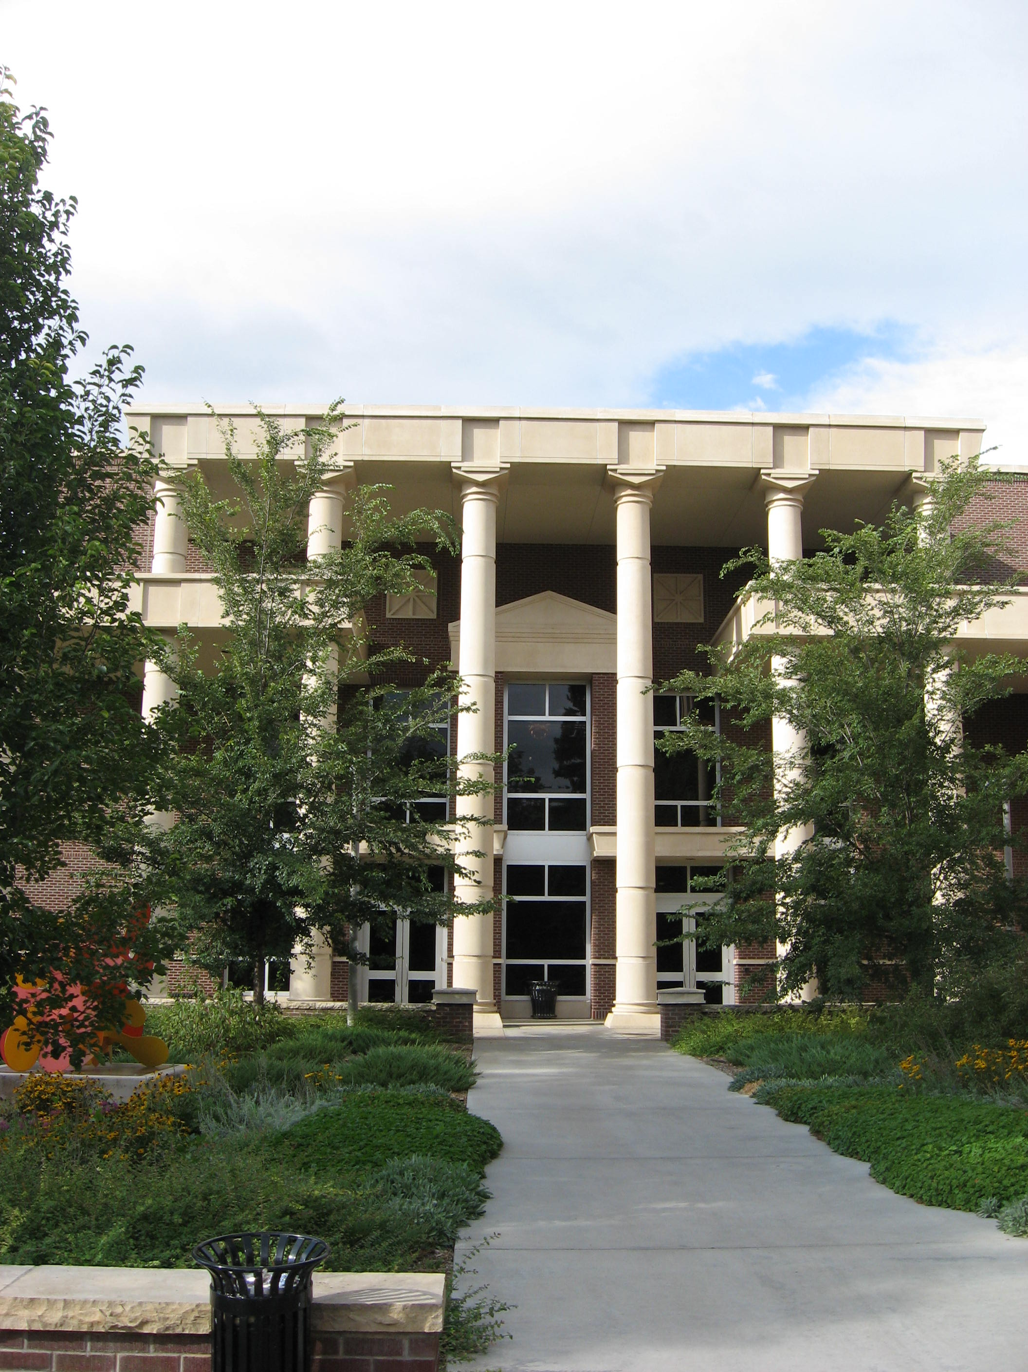

Fig 17, The octagonal split square element in Griffin Hall and the six split window of Main building
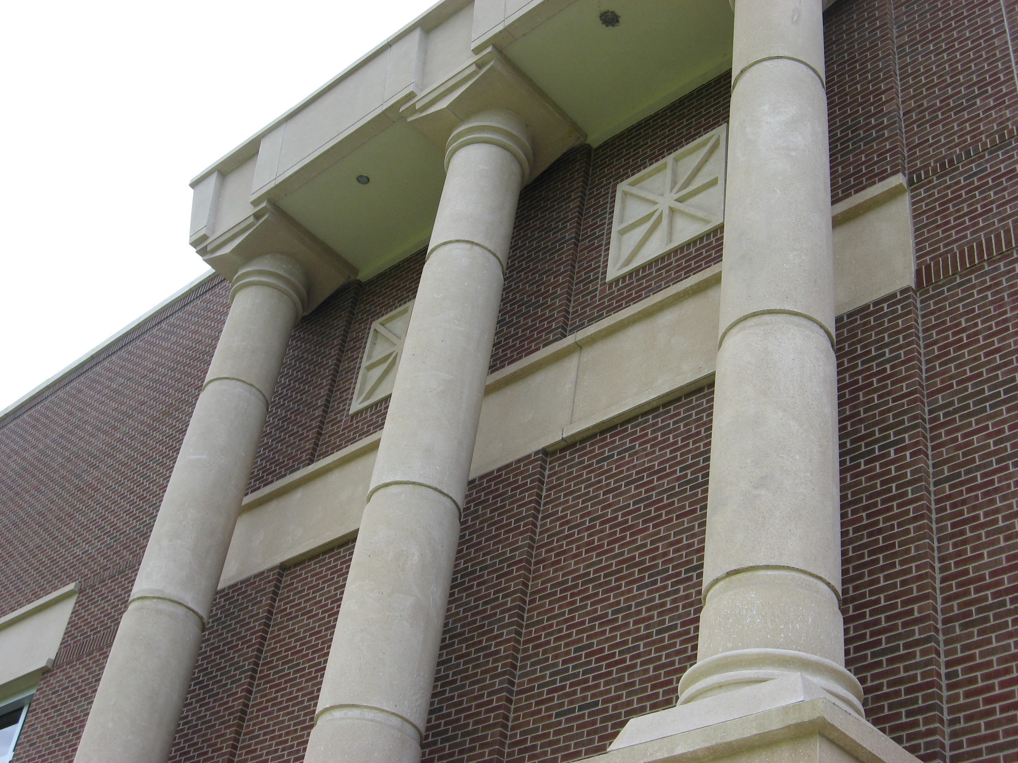

Ackerman, James S. Palladio. Pg. 19-22. Facts also confirmed by several other books.
Ackerman, pg 25-26)
E.g. “ He saw the distance between the columns as an integral part of each order with, for instance, two and a quarter column diameters serving as the intercolumniation for the Ionic order, and two for the Corinthian. The order thus becomes –for the first time in Renaissance architecture –a potential generator both of two dimensional and three dimensional schemes. “ ( Burns, pg. 4, from the Introduction to Andrea Palladio: The Complete Illustrated Works)
Ackerman, pg. 27
i.e. country houses
Farber, Joseph C and Henry Hope Reed. Palladio's Architecture and its Influence: a photographic guide. Pg xi
Wittkower, Rudolf. Palladio and Palladianism. Pg. 15
Curl, 203
Whiffen, Marcus. American Architecture : Vol. 1 1607-1860, pg. 68
Peter Harrison was actually America’s first professional architect (1716-1775), who brought Palladianism to the country through the Redwood Library in Newport and the Brick Market in Newport, as well as King’s Chapel in Boston. Farber, pg.107
Farber, pg. 107
Whiffen, American Architecture Since 1780, pg. 31
Upton, Architecture in the United States.pg. 21
Whiffen, American Architecture Since 1780, pg. 33
Whiffen, American Architecture Since 1780, pg 34
Electa Editric, Published on the occasion of the “Palladio in America” exhibition, Milan. 1976, as found in “Palladio in America”
McClintock, pg. 5
Donovan, School Architecture: Principles and Practices. pg 27
Dunn, as found in Pike, pg. 16
Ibid.
Pike, chapters 1 and 2 - The actual building of Fort Collins High School cost $330,000, and its Architect was William N. Bowman of Denver. It was built using brick backing for the exterior walls to provide a sturdy construction, with face brick made by Colfax Pressed Brick Company of Denver.
Ibid.
Guidolotti, pg.158 and 173
Curl, 138
Ackerman, 182
Curl, 34
Curl, 100
Ackerman, 160
“ The simplest of the five Orders of Classical Architecture, The shaft of the column is never fluted, and the capital has a square abacus. The base consists of a square plinth and a large torus, and the entablature is quite plain. In a primitive version of the Order, the frieze and cornice are omitted and a wide overhanging eaves carried on long mutuleS is placed directly above the architrave. The Tuscan cavaedium had an inward tilt in all for directions so that rain drained through the compluvium. ( Curl, 219)
Ackerman, 86
Whiffen, American Architecture since 1780, pg. 31on Jeffersonian Classicism = “ The quintessential Jeffersonian building is of red brick with a white portico of the Tuscan proder or of unfluted Roman Doric. ( Ionic and Corinthian are much rarer.) Very often there is a semicircular window in the pediment. The effect of the portico is one of weight and massiveness ( as against the lighteness of an Adam Style portico). It may be the central feature of the front, or the whole building may be of temple form. In either case, the plan of the building is unlikely to beof any but rectilinear outline; polygonal projections may occur, but elevations, with straight-topped windows, though there may be a semicircular fanlight over th front door. Floors are of low, pedimental pitch, sometimes concealed by balustrades.”
Balusters- “ a small colonnette or post forming part of a balustrade and supporting a handrail or coping. It can be square, polygonal, or circular in plan, and its profile can be elaborate. Balusters are also known as columella balustrade. ( Curl, 178)
Wittkower, 41-48
Curl, 174, 189 (fig. 27)
Cordes, Jennifer, Slauterpaull architects, email interview, Fall 2009.
BIBLIOGRAPHY Ackerman, James S. Palladio. New York: Penguin Books, 1966. Barnard, Henry. Henry Barnard's School Architecture. edited by Jean and RObert McClintock. New York: Teachers College Press,1970. Burden, Ernest. Building Facades: Faces, Figures, and Ornamental Detail. Ernest Burden, 1996. Burns, Howard. " Introduction." Andrea Palladio: The Complete Illustrated Works, photographed by Pino GUidolotti. New York: UNIVERSE, 2000. Cordes, Jennifer. SLAUTERPAUL ARCHITECTURE. September 2009, email interview. Curl, James Stevens. Classical Architecture: An Introduction to Its Vocabulary and Essentials, with a Select Glossary of Terms. New York: W.W. Norton & Co., 1992. Donovan, John J. and others. School Architecture: Principles and Practices. New York: THe Macmillan Company, 1921. Farber, Joseph C and Henry Hope Reed. Palladio's Architecture and its Influence: a photographic guide. New York: Dover Publications, Inc., 1980. McClintock, Jean and Robert. Henry Barnard's School Architecture.New York: Teachers College Press, 1970. Upton, Dell. Architecture in the United States. Oxford, New York: Oxford University Press, 1998. Whiffen, Marcus. American Architecture Since 1780: A Guide to the Styles. Cabridge, Massachusetts: The M.I.T. Press, 1969. —. American Architecture vol. 1, 1607-1860. Cabridge, Massachusetts: The MIT Press, 1981. Wittkower, Rudolf. Palladio and Palladianism. New York: Geory Braziller, 1974. List of Illustrations Fig 1, example of Palladian Villa, Villa Badoer, Guidolotti, Pino.Andrea Palladio, The Complete Illustrated Works. New York: Universe. 2000. pg 154-55 Fig 2, Monticello, Whiffen, Marcus. American Architecture Since 1780: A Guide to the Styles. Cabridge, Massachusetts: The M.I.T. Press, 1969. Fig. 3, Thomas Jefferson's Virginia State Capital, Richard Bland College Library, "Rededication of the Virginia Capitol @ your library," www.rbc.edu/.../capitol-rededication_2007.html Fig. 4 Neo Classical Revival, Whiffen, Marcus. American Architecture Since 1780: A Guide to the Styles. Cabridge, Massachusetts: The M.I.T. Press, 1969. Pg. 168 Fig. 5- Palladio’s Villa Barbaro and Villa Emo. Guidolotti, Pino.Andrea Palladio, The Complete Illustrated Works. New York: Universe. 2000. Pg 158-159, 172-74. Fig. 6- Kent’s Holkham Hall in Norfold, built in 1734 to 1765. Curl, James Stevens. Classical Architecture: An Introduction to Its Vocabulary and Essentials, with a Select Glossary of Terms. New York: W.W. Norton & Co., 1992. Pg. 138 Fig. 7- Expanded Stair Landing in FCHS, Birdsall, Kaitlyn. Photos from Fort Collins High School and Renovations. Fall 2009 Fig. 8 –Old Fort Collins High School building façade, photo by Denise Birdsall, fall 2009. Used with permission. Fig. 9 Palladio’s La Rotunda, Guidolotti, Pino.Andrea Palladio, The Complete Illustrated Works. New York: Universe. 2000. Pg 65 Fig 10. Palladio’s Basilica, Guidolotti, Pino.Andrea Palladio, The Complete Illustrated Works. New York: Universe. 2000. Pg 31. Fig. 11- Serlio Motif, Fig 57 & 58. Curl, James Stevens. Classical Architecture: An Introduction to Its Vocabulary and Essentials, with a Select Glossary of Terms. New York: W.W. Norton & Co., 1992. Pg.212. Fig. 12-Wing window of Fort Collins High School, photo by Kaitlyn Birdsall. Fall 2009 Fig. 13-Balustrade , Wittkower, Rudolf. Palladio and Palladianism. New York: Geory Braziller, 1974. Pg 47 Fig. 14-Pediment Windows, from Palazzo Iseppo da Porto ( from I Quattro Libri dell’ Architettura), Wittkower, Rudolf. Palladio and Palladianism. New York: Geory Braziller, 1974. Pg 46 Fig. 15- Birdsall, Kaitlyn. Photos from Fort Collins High School and Renovations. Fall 2009 Fig. 16 Birdsall, Kaitlyn. Photos from Fort Collins High School and Renovations. Fall 2009 Fig. 17 Birdsall, Kaitlyn. Photos from Fort Collins High School and Renovations. Fall 2009 Fig. 18 Birdsall, Kaitlyn. Photos from Fort Collins High School and Renovations. Fall 2009

