University of York
Hardwick Hall
An Architectural Biography of the Life of Elizabeth Talbot, Countess of Shrewsbury
Kaitlyn Birdsall
24/5/2009
Anne Marie Akehurst
English Country Houses, Summer 09
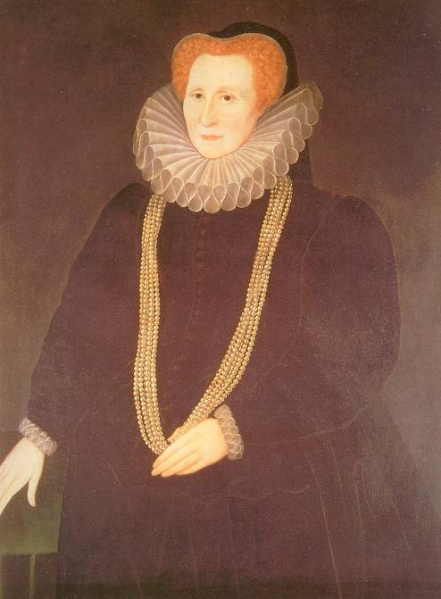

Hardwick Hall was built to inspire awe –its symmetrical plan and mullion paneled windows are an ode to the Elizabethan time. One of the only surviving Elizabethan ‘prodigy’ houses, it sheds much light on how a house can be a clever ‘device’: the plans appearing as two interconnected Greek Crosses, it looks symmetrical outside, yet its rooms overlap the outside windows and often use fake windows. This oddity was built with purpose in mind, and its rooms can do more than tell of its function, they tell a story. This is the story of its patron builder Elizabeth Talbot, Countess of Shrewsbury, a woman who rose from the family of a country squire to become a woman at the pinnacle of power, whose descendants would be among the ruling elite of England for centuries to come. A rare woman with“ a singleness of purpose, shrewd understanding and managing ability…[Bess built Hardwick as] the ultimate expression of her achievements.” Her choice of the site for Hardwick, her first building of Old Hall, and the exterior and interior purposes of New Hall can be interpreted as a biography of its patron builder, Bess of Hardwick.
The choice for the site reflected Bess’s early childhood experiences. She was born in Hardwick manor around 1527, although the building was most likely a small manor house with a capital value of £28. Her father John Hardwick died shortly after her birth, leaving a young family with an heir that was too young. Instead, all of the lands and income that those lands made would go to the Office of Wards until the young heir, James, came of age –effectively leaving the widow and her family without any means to live. To escape this, Bess married to Robert Barlow, who was the heir to the Barlow estates. Unfortunately, he died before coming of age, leaving Bess once again at the mercy of the Office of Wards. These experiences hardened her resolve, and when she later married to William Cavendish, “ the new house and lands were registered in the names of both Bess and [William]…to protect the interests of their children should Sir William die before the eldest son came of age.” When she bought Hardwick in 1583 for £ 9500, it was with the money that she got from this agreement with William Cavendish years before. Perhaps she had bought the land as if to say that she had a birthright to it, and now that she finally had a means for herself, she could claim that right. She had gained the knowledge from previous experiences and learned how to use the Office of Wards to her advantage, using her wit to become one of the most powerful women in the entire country. The Hardwick land could no longer be touched by the Office of Wards, and when she got into a quarrel with her last husband, George Talbot, Hardwick was the only property that she could indisputably label as her own, with her husband having no claim to it.
Bess was a very successful and cunning woman, driven by ambition and direction –yet by analysing her first building structure at Old Hall, which appears as a failure, it cannot help but tell another story in Bess’s life: her failing marriage to the Earl of Shrewsbury. Bess had met George Talbot, the Earl of Shrewsbury, in court when she once again found herself without a husband for a fourth time. She being one of the Queen’s ladies-in-waiting, and he being the Queen’s right-hand man, the match seemed well off, until the Queen gave the Earl the heavy and thankless job of being the guardian of the exiled Mary Queen of Scotts. In 1583, the Earl, after years of being worn down by this heavy burden, along with his children and his wife wearing down his pocketbooks, seemed to want to put all the blame on the sole shoulder’s of Bess. After the dispute, she was forced to flee to Hardwick –most likely still in its humble beginnings even if James Hardwick had built onto the preexisting house –and Talbot ordered all of her tenants to pay him instead of her. Without funding, Bess was keen to make amends. Writing to Talbot, she beseeched him: “ My Lord, how I have tended your happiness…hatred must grow of something and how I have deserved your indignation is invisible to me…I trust you will quieten my heart, receiving me into your favour, for only you can do it.” This uncertainty and drift from her usual ambitious behavior is carved into the very walls of Old Hall, making it “curiously disorganized, as though Bess had been uncertain of her aims in [those] troubled years.” Without a stable income, Bess did not begin building until after 1587 when the dispute between husband and wife was taken to court and was found in her favour, forcing the Earl to give her back the £2,000 he had collected from her tenants. Still, the Earl continued to give trouble, refusing to pay the fee at one point. Out of bare necessity, she began building Old Hall to accommodate herself and her son William’s family, who was living with her, but she did not plan ahead and there was no architect involved. She most likely delegated the building process herself with the help of her clerk of work, David Flood, and a group of skilled masons.Yet she was no architect and did not have the means to convey what she wanted, resulting in Old Hall having, “ no architectural concept; the window mouldings on the east wing( panel 1) differ from those on the rest of the house; part of the exterior is rendered, part ashlar-faced; the roof of the centre portion is gabled and slated and the two wings were flat; the building lines are not parallel, and there is no attempt at a balanced elevation anywhere(panel 2).” Unplanned, it did not have any sense of convenience, as seen in the layout of the rooms (panel 3), her drawing room being on the floor above her room. While she is confident in almost every other part of her life, this was her lowest point. The disorganization of the building reflected Bess’s life at the time, with her trouble and doubt over her husband as well as her unstable income. Still, once she had an income coming in, she did begin to make her interior beautiful, and in 1589 began work on her Forest Great Chamber (panel 4), with finer ashlar workings that would hint at the structure she would begin a year later.
New Hall is the culmination of all of Bess’s ambitions, displaying her personal taste in every part of its structure and built on the knowledge and experience of her long life. Built with the intention of being the home of what she hoped to be a successful dynasty in her son William, nothing was spared. It was begun after the Earl died in 1590, leaving Bess, as per the marriage settlement, one third of all of his estates. During this time, Bess’s gross annual income was £8300, £3000 of that coming from the Talbot marriage settlement. With such an increase in funds, and getting along in years, she did not spend this money on going to the royal courts, but focused instead on building greater than any of her previous works. She had learned from Old Hall, and she did not leave room for mistakes at New Hall, which showed the perfection she expected and “[was] the ultimate expression of her achievements.” The building’s symmetrical layout and identical fronts (panel 5) could be compared to her expectations of her family. She set strict boundaries to follow and expected perfection, and those who did not act accordingly were written out of her will completely. Thus was the case for her ‘bad son’ Henry, who deviated from the strict course Bess set for him, in addition to never providing any legitimate male heirs, and was thus pruned from Bess’s family tree. Arbella, her much anticipated granddaughter and possible heir to the throne, also proved difficult later on, and became estranged from her grandmother because of it. She wanted her family to look elite and be accepted into the peerage system, and she made it a point to have all the appearances of the elite in her house. Fine course ashlar and well proportioned mullioned windows also lead to the appearance of wealth and power. Yet, Bess was once again cunning in the way she devised her building: all of the materials came straight from her estates, and she never had to buy it.
The style of the house also speaks greatly of the woman who built it. Robert Smythson, the architect believed to have designed Hardwick, planned “ the whole house [to be] square in feel, and this squareness emphasized by the great mullioned windows…”gave the impression of a much larger house than it actually was(panel 6). In fact, it only contained 14 chambers, and needed the use of Old Hall to provide housing for any other guests. It does not show great influence of classicism –even with the loggia –which reflects on Bess’s never having traveled outside of England. She, at least ostensibly, focused all of her energy on her Lady Queen who was the leader of the Protestant cause.
Another object of interest which points to Bess’s obvious pride is the initials on the top of each turret (panel 7). Clearly, she wanted everyone to know who the founder of such a great house and family was, and it was not to any of her husbands who received that credit at Hardwick. Her blatant pride doesn’t stop there: she also has the stags of Cavendish strewn everywhere about Hardwick -from the arms on top of the east and west fronts (panel 8) to the “enormous heraldic overmantels… proclaim[ing that] her lordship and her authority [was] not to be doubted.” These shout her ambition for the Cavendish namesake to rise above all, and her pride for her children, at least for the ones she acknowledged. All of these speak volumes about the character of the prestigious Elizabeth Talbot. She had reason for pride in light of how she comported herself and built her dynasty throughout her long life.
Hardwick New Hall shows the extent of Bess’s involvement in its planning and construction, since she was “not the sort of person to leave the details of her house to others.” Bess was there during the making of her house, and only she could approve of changes to the original design. One of the most visible changes in Robert Smythson’s design is the height of the towers, which were raised another level above the height of the house(panel 9), giving it a less solid feel. She also certainly approved of the loggia being restricted to only the east and west fronts (instead of completely surrounding the house), giving the towers more emphasis on the ground level. This once again shows her stubbornness and attention to all the details, traits apparent in every aspect of her life. In the account books of Hardwick and Chatsworth, she overviewed every entry and sometimes made corrections to it. She was always in the centre of things, whether that be at court, in buying more land and keeping accounts, or in the actual structural design of her home and her family.
The inner workings of the house and the ingenious design in which all the rooms fit together can be taken as a metaphor for the connections Bess made in life for her family. From the outside, Hardwick New Hall appears to be as symmetrical on the interior as it is on the exterior, but that is not the case: “ Several of the great windows are false, or light two floors of low ceilinged rooms instead of a single lofty one; the High Great Chamber is over to one side instead of above the central hall, as the outside elevation might suggest(panel 6).” This overlapping and fooling of the eye is once again an insight into its patron, who would overlap connections to keep herself in the highest possible point in court. She did this through asking key figures to be the godparents of her children, each in high social standing, and several royalty. For example, soon -to-be Queen Elizabeth became the godmother of William Cavendish and Elizabeth’s first son, Henry, in 1550. To keep her family completely safe and well connected even in harsh times, she asked the Catholic Queen Mary to be the godmother of her third son, Charles. Yet she also asked the Protestant leader Henry Grey, who was highly antagonistic towards Queen Mary, to be godfather, forcing even royalty to work together to do her will. Like her rooms in Hardwick, she overlapped and fit together every aspect of her social and political life to serve her overall ambitions and plans.
The rooms of Hardwick were also designed with the purpose of ceremony in mind, which was instrumental in Bess’s life. Placing the most important chamber at the top allowed for important people’s “approach (to) be made very long and magnificent, with plenty of room for incident and drama.” Presentation was everything to Bess, because that was how she had been able to climb the social ladder for so long. The dramatic stairway entry(panel 10) into the High Great Chamber at New Hall hinted at the intrigue and drama that Bess experienced in her life, relying on her wit and beauty to snare four husbands that were much higher above her in class and money. By having such a wide staircase, the house gains a feeling of grandeur, as if money, which increased exponentially as space increased, was unimportant. Appearances were everything to Bess, because the game at Court demanded such.
The High Great Chamber is built in dedication of the woman whom she based her life around and who helped her in troubled times, Queen Elizabeth. Bess had a strong connection to Queen Elizabeth, from being one of her ladies-in-waiting, to many other interactions. When trouble brewed between Bess and her husband the Earl of Shrewsbury, a man who was extremely loyal to the Queen, she still favoured Bess and the court case thus fell in Bess’s favour. The High Great Chamber seems to echo the thanks and respect that she has for this woman, the entire plaster frieze surrounding the chamber dedicated to the Diana, a representation of the virgin Queen (panel 11). Above all her pride for herself and her Cavendish sons, she understands she could not get anywhere without the royal patronage of the Queen. She may have built the Chamber in the hopes that the Queen would actually be able to come to Hardwick, although this never was the case. She may have had high hopes for her granddaughter, Arbella, to follow in the footsteps of her great aunt Queen Elizabeth, but once again her hopes fell short. Yet for certain, whoever walked into that Chamber would have it enforced upon them that Bess had high connections and valued those above everything else.
Hardwick Hall “remains the supreme triumph of Elizabethan architecture,” leaving historians a house preserved in time, telling the story of an age, and also telling the story of an individual woman. Hardwick Hall is a reflection of its first owner in every way, from the site it is built on and the first building she built there, to the final production of New Hall. Because it shared so many of Bess’s interesting quirks and driving ambitions, later generations were unable to alter it, keeping it preserved as it was in Elizabethan times. Bess of Hardwick left her mark on the country through her buildings and through her descendants. To this day, she refuses to be forgotten, leaving Hardwick as a memento to her life.

Bibliography
Durant, D. (1977). Bess of Hardwick: Portrait of an Elizabethan Dynast. London & Chester Springs: Peter Owen.
Girouard, M. (1983). Robert Smythson and the Elizabethan Country House. New Haven and London: Yale University Press.
Goldring, E. (2004). Talbot, Elizabeth ( Bess of Hardwick), countess of Shrewsbury ( 1527?-1608). Retrieved May 22, 2009, from Oxford Dictionary of National Biography: http://www.oxforddnb.com/view/article/26925
Levey, S. (1998). An Elizabethan Inheritance: The Hardwick Hall Textiles. London: The National Trust.
Stallybrass, B. (1912-13). Bess of Hardwick's Buildings & Building Accounts. Archaeologia , 347-398.

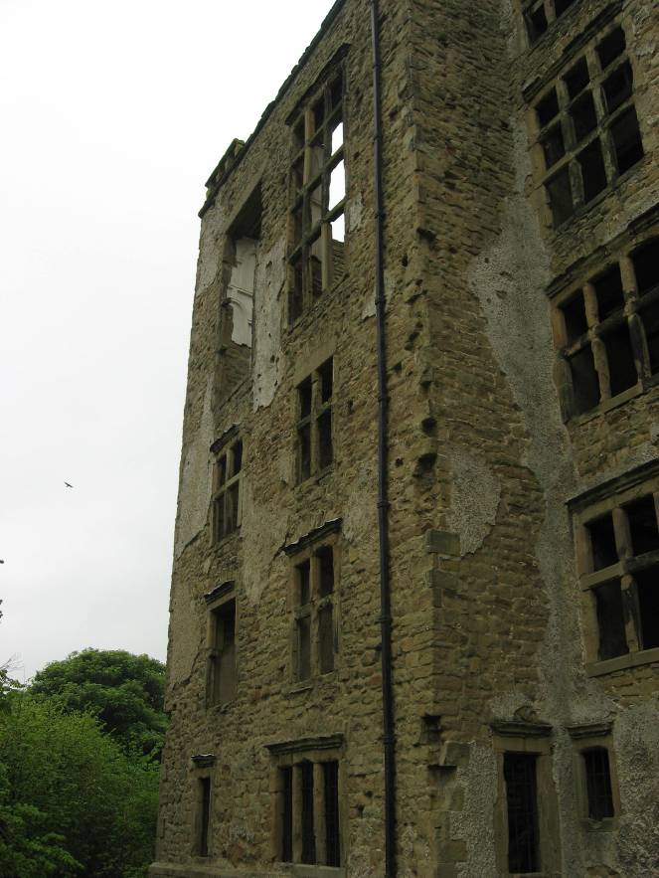
Photo by Kaitlyn Birdsall
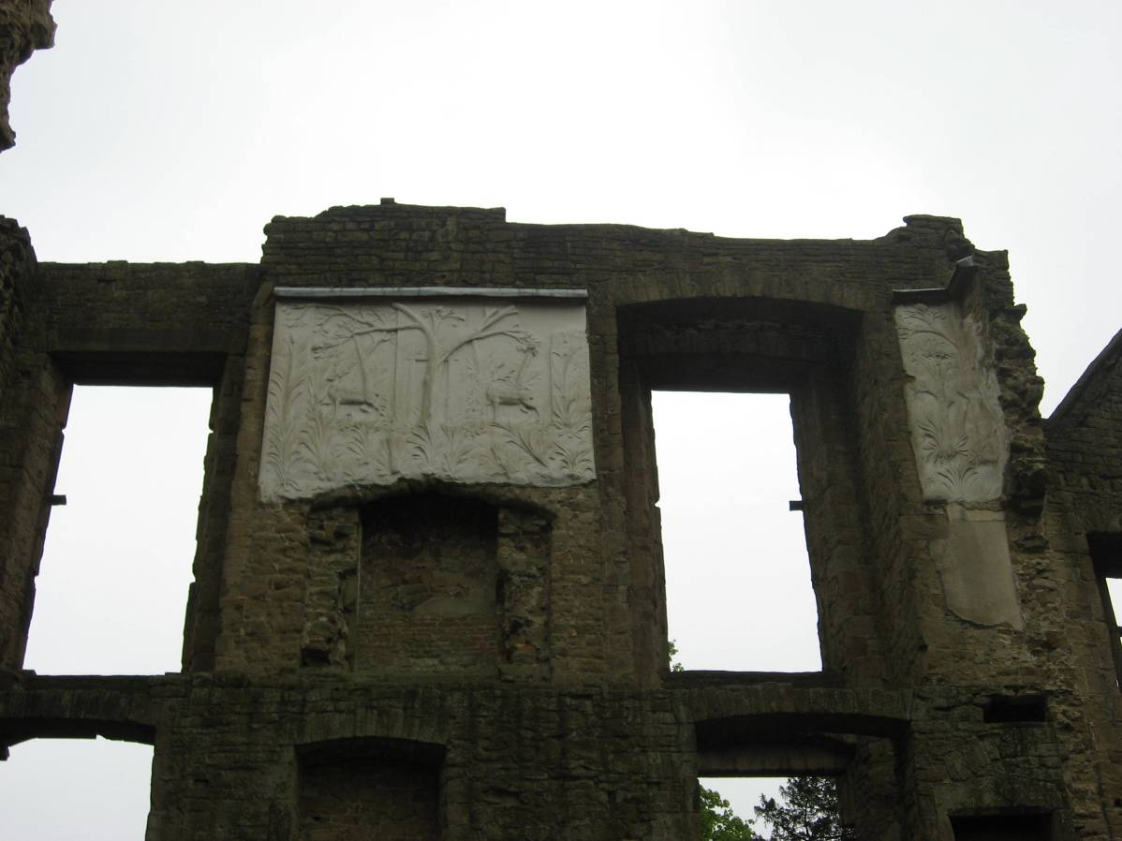
Picture by Kaitlyn Birdsall
Panel 1-Window moulding on east wing
Panel 4- Great Forest Chamber, Old Hall, remains.
Panel 3- Old Hall floor plans displays the unorganized layout of the rooms ( see page 8) ((Stallybrass))
Panel 2- Hardwick Old Hall Elevations show uneven elevation and disorganized plan (see page 7) ((Stallybrass))
Panel 6- plans for Hardwick New Hall, designed by Robert Smythson (?). Recognize the rectangular and square shapes that make up its design. Notice how the rooms do not match up together and do not display the exterior symmetry.
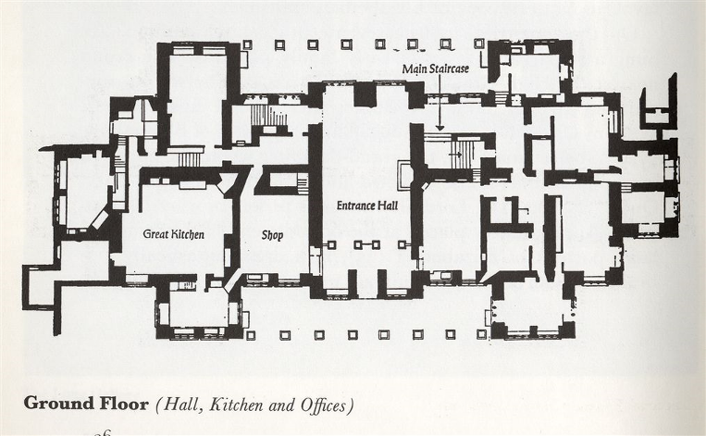
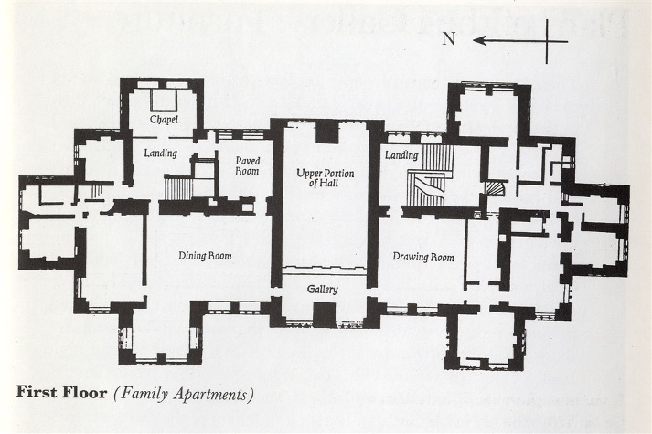
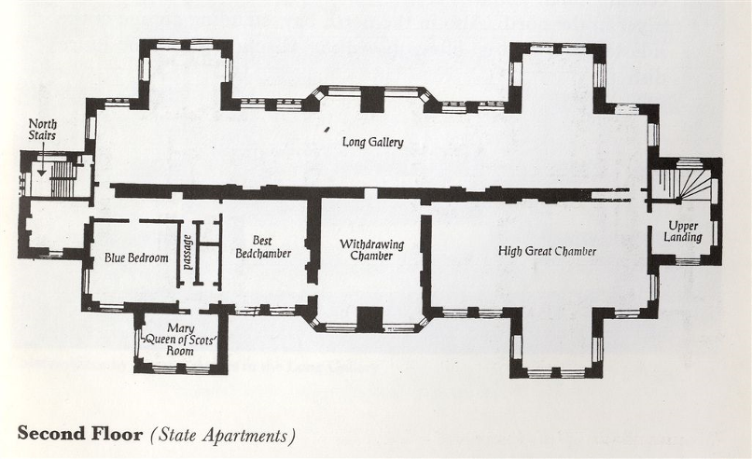
Panel 5- identical fronts of the east and west of Hardwick New Hall
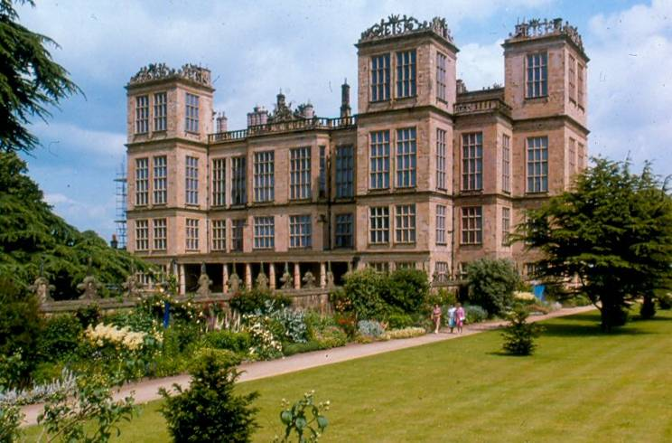photo from VLE, west front
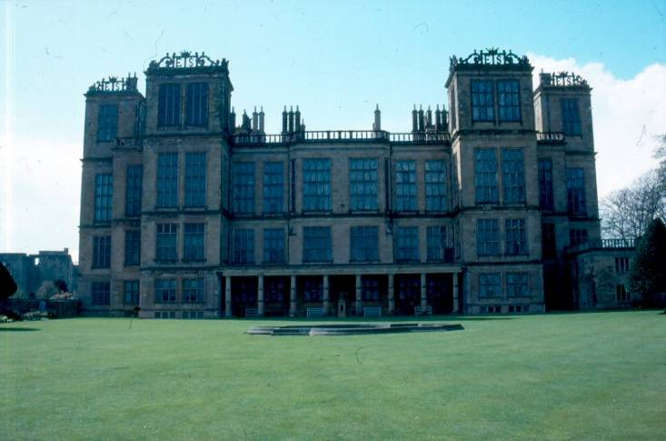 photo from VLE, east front
photo
Panel 11- the High Great Chamber, dedicated to Queen Elizabeth
Panel 10- dramatic main stairway up to the High Great Chamber
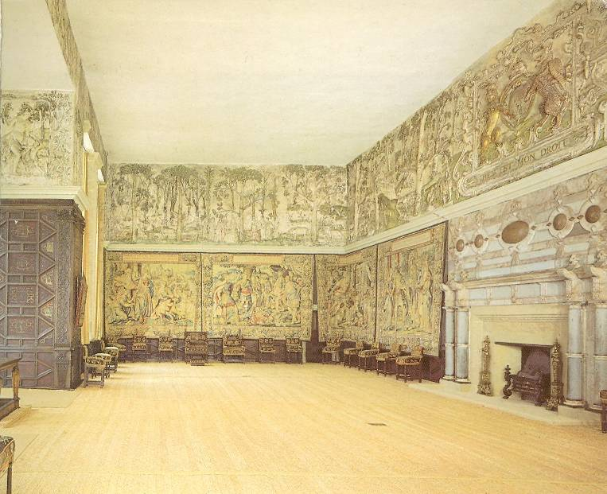 photo by VLE
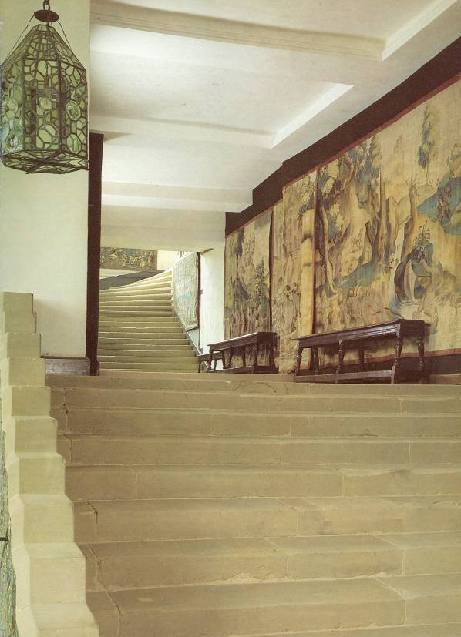 photo by VLE
Panel 9- west front, view of tower elevation
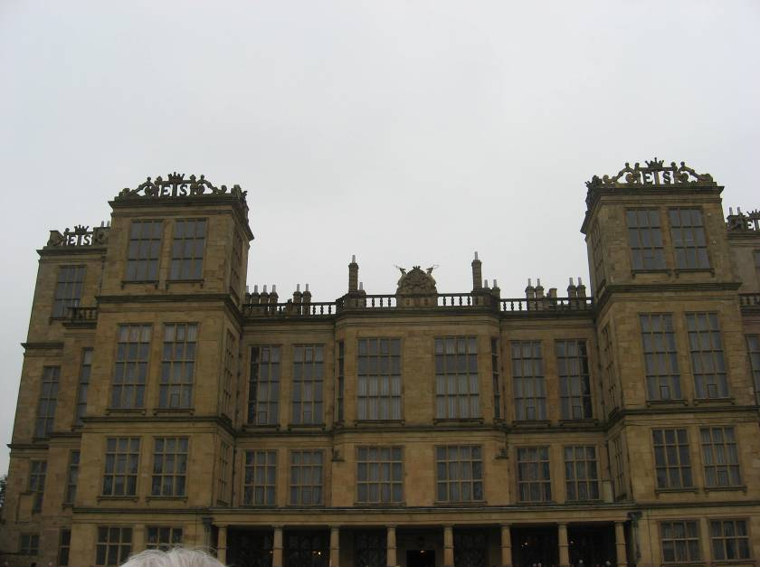
Panel 7- East front view of initials on turrets
Panel 8- west front view of Cavendish coat of arms. Originally this was on both the west and east front.
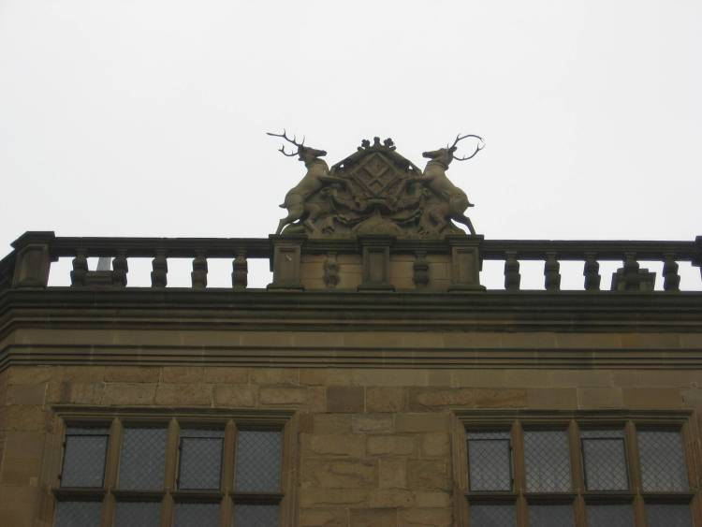
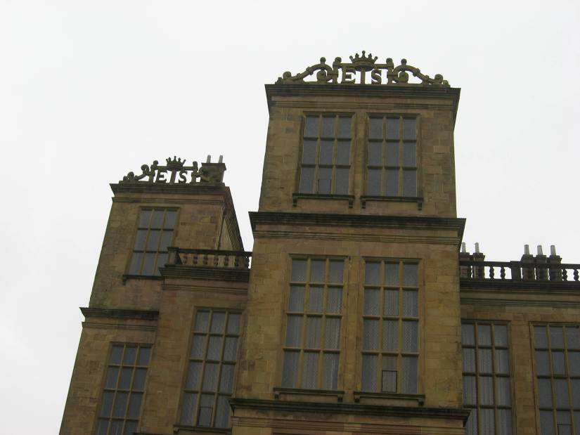 photos by Kaitlyn Birdsall

Durant, D. Bess of Hardwick: Portrait of an Elizabethan Dynast. Pp. 1-2
Durant, Bess of Hardwick p.162.
Sallybrass, B. “Bess of Hardwick’s buildings & Building Accounts.” P. 348
Levey, S. An Elizabethan Inheritance: The Hardwick Hall Textiles.p. 1
Durant, D. Bess of Hardwick: Portrait of an Elizabethan Dynast. P. 104
Durant,D. Bess of Hardwick.p. 154
Durant, p. Bess of Hardwick148
Girouard, Robert Smythson p.144
This date is disputed, as all my sources say differently. Durant: 1584, Oxford DNB:1587, Stallybrass: 1586
Durant, D. Bess of Hardwick p.156
Durant, D. Bess of Hardwick. P 154
Sallybrass, “Bess of Hardwick’s buildings…” p.367
Durant, Bess of Hardwick pp. 180-190
Durant, Bess of Hardwick p. 162
Girouard, Robert Smythson. P. 149
Durant, Bess of Hardwick p. 198
Girouard, Robert Smythsonp.160
Girouard, Robert Smythsonp.148.
Sallybrass, “ Bess of Hardwick’s Building…” p.350
Girouard, Robert Smythsonp.153.
Durant, Bess of Hardiwckch p. 2
Girouard, Robert Smythson p.156
Durant, Bess of Hardwick
Girouard, Robert Smythson p. 146

