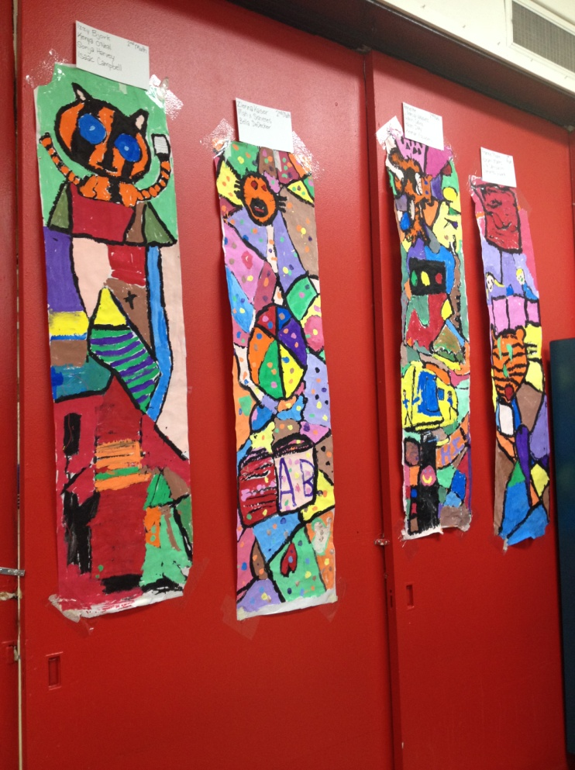
Community Collaboration Project
2nd grade
1/22/2014
Time: 4 hour long classes
Abstract:
Art can make something ugly beautiful, just like the transformer boxes in Fort Collins and Loveland. Art can be made by the community and for the community. Community art is intended to be viewed by the community: it isn’t in a museum, it is in the place that it represents. Community Art can be made by one artist or many. While it can be made by an artist that isn’t part of the community, the community helps pay for community art so the community has a say in how the art will look.
Lesson Objectives:
- I can recognize that art has a place in my community by relating personal experience to the community art I see ( Bloom’s: Evaluate/Standard: Transfer/ GLE: Visual arts respond to human experience by relating art to the community
- I can identify that art can communicate ideas without using words (Bloom’s: Apply/Standard: Reflect/GLE: Visual arts uses various literacies to convey intended meaning)
- I can create my own symbol that represents my personal experience to the school community in a sketchbook ( Bloom’s: Create/Standard: Create/ GLE: Use familiar symbols to identify and demonstrate characteristics and expressive features of art and design)
- I can collaboratively create a mural that will represent our school community in order to beautify the school ( Bloom’s: Create/Standard: Create/ GLE: Use familiar symbols to identify and demonstrate characteristics and expressive features of art and design)
- I can create a mural that uses tempera effectively and work with a group of peers cooperatively (( Bloom’s: Create/Standard: Create/ GLE: Use familiar symbols to identify and demonstrate characteristics and expressive features of art and design)
Resources:
- Transformer Boxes of Loveland
- Universal symbols
Materials:
- Chalkboard to write ideas
- Sketchbooks
- Pencils/erasers
- White butcher paper cut to 60 “ long, 1 per table
- Tempera paint
- Cups
- Brushes
- Masking tape
- Aprons for students
Anticipatory Set:
Should art that is seen by the community be liked by the community? Should community members have a say about what public art is displayed?
What are some community artworks that you have seen here in Loveland?

Instruction/Procedure:
Teacher Does… | Student does…
Last week, we did a project where we made a clay symbol. What is a symbol again? | A simple something that represents something else. Like the hearts representing Loveland!
So we looked at two different artforms that are here in Loveland: the hearts and the transformer boxes. Well today we will focus on the boxes.
First off, what is community art and why should we have it? Can someone tell me what community art is and what its for? | It is art made to represent the community and it is displayed in the community it represents.
Yes! Community art is made for the community, about the community, and often by the community. Community art is not hidden in a museum, it is out in the open so that the community can experience it. It is paid for by the community so the community has some say as to what the art is about and artist often have to make a sketch or examples before a community will have that art. The art REPRESENTS the community it is in. It can be made by one artist or multiple artists. Often it is made by someone who is from the community, because who represents the community better than a community member?
How many of you have seen this transformer box of the dinosaurs? Well has anyone looked at it closely? What is on the dinosaurs? This transformer box was COMISSIONED by the community. Commissioned means that the community helped pay for it. Why do you think it was so important for the community to get these boxes painted? Is there a purpose? | Raise of hands  Its of Dinosaurs and it has famous paintings on the dinos  They thought it was really important to make them nice to look at
So this artist was given a THEME to work with, which was art and science. See how he combined the two themes together? This was his interpretation, meaning what he thought about when he heard the theme. He chose to think of things that could represent both art and science. He felt that dinosaurs was something that could SYMBOLIZE science, while famous paintings could SYMBOLIZE the importance of art. What does SYMBOL mean again? | Symbol is something that represents something else.
We are just going to quickly go over symbol again just to make sure you know it. What is this a SYMBOL for? If you saw just a red light, would you also stop? | STOP
Symbols are VISUAL REPRESENTATIONS that are simple and easy to understand. Often there are UNIVERSAL symbols that are used to represent different things because there is no LANGUAGE BARRIER with visual symbols. Can you tell me what some of these symbols mean? | Identify symbols
SLIDE SHOW OFF: So let’s get back to the community. What do you think of when we say COMMUNITY? | Answer
Did you know that your school is a community? How do you think it is a community?
Well here is the deal! You are in for a special treat…we are COMMISSIONING you to paint a mural! We want you to create SYMBOLS that represent our school and what makes us DIFFERENT!
There are some pretty ugly cabinets/doors that need something to brighten them up. Just like being a TRANSFORMER BOX ARTIST, you are going to come up with an idea for our theme SCHOOL COMMUNITY. You are going to sketch out your idea. Then you will COLLABORATE with the people at your table to create a mural that is as big as your table that we will then hang on those ugly doors! I hope you are excited!
First off, it always helps to brainstorm. So first we will brainstorm together. What is something that represents our school? What makes our school special? Who is important? I will write them down on the board | Students say suggestions  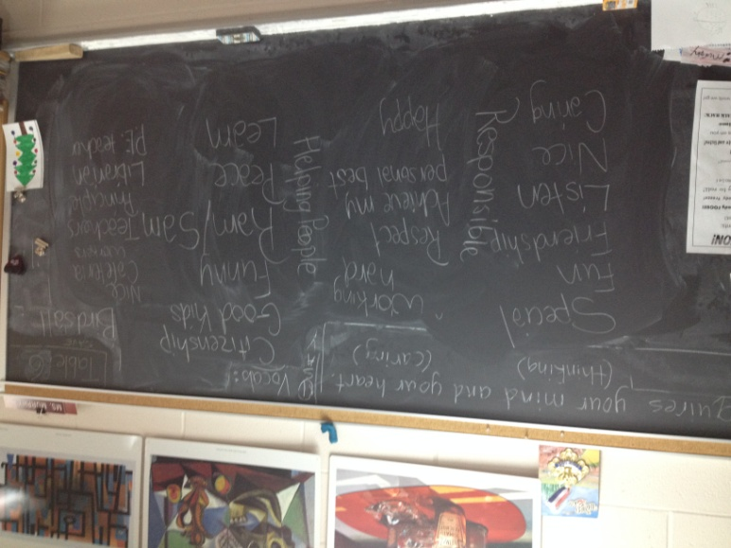
So you will come up with your own symbol for the school. Remember that you will all be working on the same mural, so try to have different symbols. If one of you will do the ram, no one else should be drawing the ram at your table. I need you to briefly COLLABORATE. That means that you talk at a level 1 voice with your team. You can bounce off ideas with eachother. The important thing is that when someone else is talking, you are listening and vice versa. One of you can write out your collaborative team ideas in your sketchbook. | Students collaborate ideas.
Now I want you to go into your studio. Think really hard and quietly about how you want your symbol to look and how it might interact with other artists work. Now I want you to sketch that symbol in your sketchbook. Since Ms. Murphy and I are COMMISSIONING you, that means we will approve your symbol, so please raise your hand if you think you are done. | Draw individual symbol  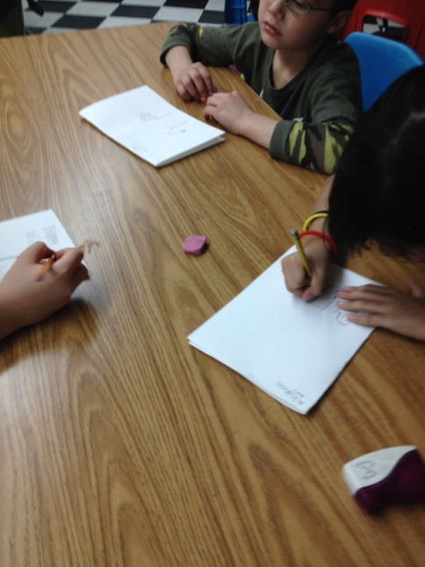
If we have time, I want to lay out this big sheet on your table. Select a space to put your individual symbol. Remember sharing and figuring out our differences is part of the whole process of collaboration. Please lightly sketch your symbol in pencil. Then write your names lightly on the back of the paper at the top. | 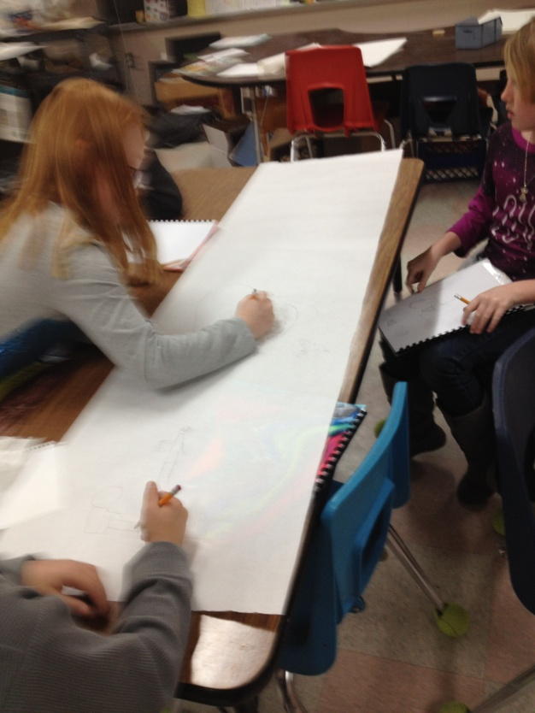
DAY 2:
Reminder/Remember: What is community? What is an example of community? Who can tell me what we were starting last week? | A group of people that are gathered for a like cause. Loveland/School/Class  We began to create a symbol that represents our school. We are going to combine those symbols on a big piece of paper that will hang on the cabinet/doors and make them prettier to look at.
Alright so the first thing is to make sure your entire mural is sketched out. Each of you will have drawn a symbol and remember that if someone is missing from your group leave space for them. When you have finished drawing your symbol, begin connecting lines to the different murals. You are trying to break up the space in the background. Each space will eventually be painted a different color, so these lines will help you separate colors and give it a stained glass appearance. Helper table will pass out your symbol notes, mural paper, and pencils. I will come around with tape so that the edges can be taped down to your table. | Helper table passes out symbol notes, mural paper, pencils, and erasers.  Students hold mural paper flat out and make sure everyone has a space on their paper. Students will draw VERTICALLY since that is how it will hang. They will draw connective lines after that.
DEMO: Gather at this finished table for the next instruction. I will call you by table to come gather, remember to take two steps back from the table so that everyone can see. | Students come up quietly and surround example table
I have black tempera paint and a rather thick brush. We have talked about how our symbols should be SIMPLE and BIG…this is why! I dip just the very tip of my paint brush in the paint so that I don’t get too much paint…think DIP DIP just the tip. I use my hand to hold my brush steady and I gently guide it over my pencil lines. FIRST I do my symbol, because I want to make sure no lines cross into my symbol. Then I go back and to all of the lines. I will hand out paint to tables that are ready while helper table passes out brushes and grabs pencils and erasers | Students who are sitting quietly receive paint and may begin.
That is all the time we will have for today: Helper table, gather paint and brushed and begin cleaning them off. I will come to a table and grab their mural to hang and dry. Any additional supplies you have out please put it away yourself. A table that is fully prepared has nothing on their table, is sitting quietly with their heads down. I will dismiss that table to line up. | 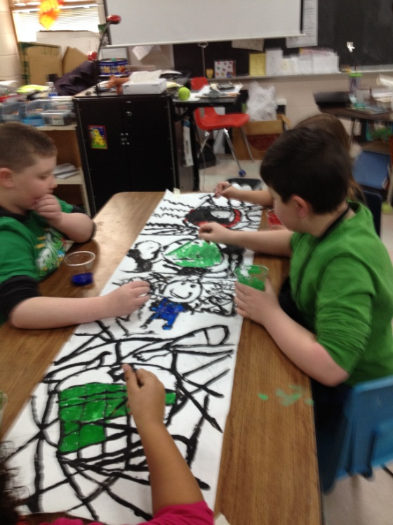
DAY 3: COLORS
What project are we doing again? | Community Mural project to make the cabinets/doors pretty to look at.
We will get our supplies out and ready in just a moment. I will choose a table that is sitting patiently and showing good TEAMWORK to do my example with. Helper table, pass out the murals and tape. Tables, you are responsible for gently spreading your mural out and putting tape on the edges. | Helper Table gives 4 strips of tape on the edge of the table after my direction. Another helper passes out the murals.  Tables will spread out their mural and tape just the 4 corners down to their table.
DEMO: I will call quiet tables to come gather around this table. Remember to take one step BACK so that everyone can see. | Students respectfully and quietly come up and surround the table
First, I have chosen 1 color. The way I will do this is I look at my symbol and figure out what colors we want. You cannot mix colors except for adding white, but we have 8 different color choices: yellow, orange, red, hot pink, violet, blue, green, brown, and peach. I have laid these out on the back counter and they are LABELED WITH TAPE. There are only 4 containers of each color. So, say your symbol is going to be green, light blue, and red. If you come back here and there are no green cups left, then grab one of the other colors you planned on using. If someone at your table is grabbing green, grab a different color that you can trade with them when they are finished. When you are finished with a color, you may either trade colors with someone at your table, or go back to the counter and trade ONE COLOR FOR ANOTHER COLOR. There are already paint brushes in each cup…leave them in the cup! Once I have selected a color, I come back to my table and carefully begin to paint. First, make sure the black paint is dry…we don’t want them mixing colors. Try to color within the lines, so be very neat. Since other parts of your mural will be wet, try not to lean up against your mural.
Please sit back at your tables. I will dismiss you by table to grab your paint. Please DO NOT RUN with your paints. Keep the paint brushes inside the cup. Roll up your sleeves. If you are wearing white, wear an apron. | Students quietly grab the paint they would like to start with. Only one of each color per table.  They will begin coloring THEIR SYMBOL first.
CLEAN UP: When I dismiss your table, you will go put aprons back, put brushes in the lefthand sink, cups in the center counter, and then wash your hands if you need it before lining up. If for any reason your tablemates become disruptive or rude, you will sit back down and be the last to line up.
Closure:
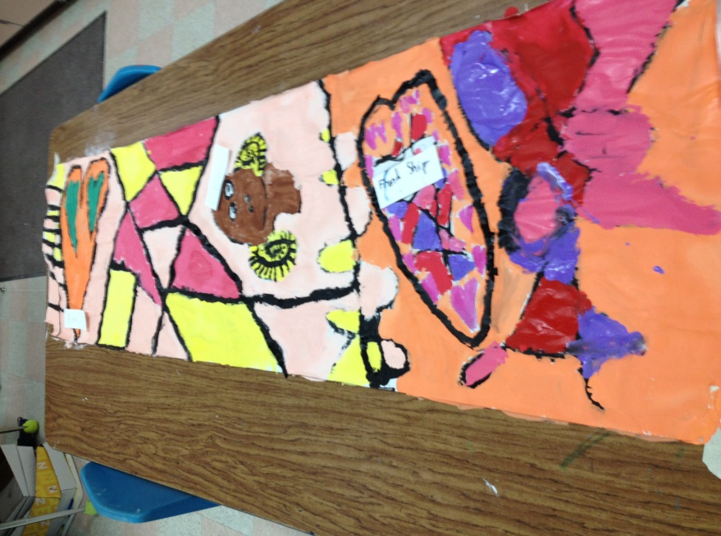
As students finish, have them write the name of their symbol on a slip of paper and put it in a bucket. When everyone is finished but the murals are still out, pass around the bucket so students can grab one symbol name. When everyone has a symbol name, they will begin searching around each mural to try to find the matching symbol to their paper. Once they find it, they put it next to the symbol then go sit down. Artists/table mates should not help people find symbols, the symbols should speak for themselves. Once all pieces of paper have found a place and all are sitting, ask students to reflect. Have them raise their hands if the piece of paper actually matched their symbol. Have them keep raising their hand if they are pretty sure the person didn’t have help figuring that out. Put hands down if their symbol was a ram/tiger. Put hands down if it was love or peace. Ask students who are still raising their hands what their symbol was. Have the person who guessed correctly say why they thought that was correct ( aka they thought it was friendship because two people were holding hands). We then discuss how symbols can be easy or hard to interpret. Ask students who couldn’t find the matching symbol to raise their hand and read out their symbol name paper. Ask why they thought it was hard to find those symbols. This reflection helps students understand how art can communicate ideas through symbolism and how they may have communicated better.

Accommodation/Modification:
- Collaboration is difficult: Students who struggle with social interaction may find this project challenging. However, they must learn to work as a team. If students are really struggling, I will intervene and respond to specific needs.
- ADD/ADHD: This project is designed for people to stand up and interact with others, so it shouldn’t be too difficult for ADD students to focus. If they are struggling with focus, I will re-direct them to their sketch ideas so that they can remember what they were trying to pain. They will be expected to have the same level voice as everyone else. Brain Breaks can break up the monotony… stretching for 5-10 seconds, etc.
- Students that finish early will be encourages to help their teammates out. If an entire table is finished but we haven’t moved on, I will decide to individually instruct those students and let them move forward, or let them have free draw to do what they want.
- Missing students: Students that are absent will be left a space to fill later on. If they miss more than 2 days, they may come up with a symbol but be unable to incorporate it into this
Assessment:
 | 4 | 3 | 2 | 1
Recognize and participate in identifying symbols in community art | Highly Participatory in class discussions, helped come up with words to symbolize the school, shared and connected other artwork in their community | Participated in class discussions, helped come up with a word to symbolize the school, made some connections in discussion | Some Participation in class discussions, made some connections in discussions | Little or no Participation in class discussions, made a few connections to discussion
Create a symbol that represents their school in their sketchbook | Made 4 different sketches pertaining to one word and the word is written in their sketchbook | Made 3 different sketches pertaining to one word and the word is written in their sketchbook /the word isn’t written/ different words | Made 2 different sketches pertaining to one word and the word is written in their sketchbook /the word isn’t written/ 2 different words | Made 1 sketch pertaining to one word and the word is written in their sketchbook /the word isn’t written/ different words
Work together to create a mural | Took a leadership role, helped teammates out, took responsibility in taking care of the space, painted symbol | Helped teammates out, took some responsibility of space (keeping clean, painting full area), painted their symbol | Took some responsibility of space, painted their symbol | Painted their symbol and the space around their symbol, but did not help or collaborate
Use of materials | Symbol is painted fully and carefully, all background is filled in, lines are clear and symbol is defined more than the background | Symbol is painted fully and carefully, all background is filled in, lines are clear | Symbol is painted fully and carefully, all background is filled in | Symbols or background not fully painted or sloppy, no lines,
Studio Habits | Continually on task and keeping others on task, discussion only centered around art, area kept clean, and followed directions | Usually on task and keeping others on task, discussion usually centered around art, area kept clean, and followed most directions | Somewhat on task, , area kept somewhat clean, and followed most directions | Not on task and distracting others, area not clean, followed few directions

