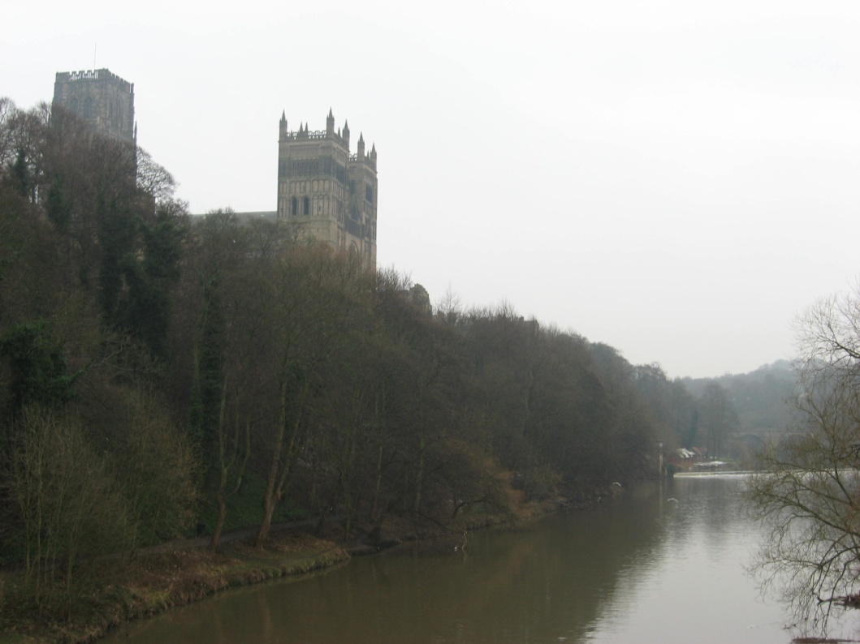Durham Cathedral:
The influence of the North
The Age of Cathedrals, C. Norton
Kaitlyn Birdsall
8/2/2009

When entering the city of Durham, the peak of anyone’s view will be captivated by the site of St. Cuthbert’s Cathedral, a structure that seems to rise out of the surrounding rivers and become the pinnacle of the steep peninsula. This massive sandstone building dominates the presence of the town, not only because of its vantage point but also because of its historical background. Durham Cathedral was constructed between 1093 and 1133, and it still stands in all its glory, making it the oldest and most influential Cathedrals in all of North England. It also represents a turning point in style because of its advanced experimental techniques that instigated Early Gothic structures. Yet the creators of Durham did not pull all of their ideas from their own mind, but were in turn inspired by previous churches. By integrating and enhancing on the designs and ideas of the churches of the day, Durham Cathedral was able to create a model used by many churches later on, setting a new standard for England and directing architecture to a new style. Due to the influence of Norman Romanesque style, Anglo-Saxon style, and Antiquity, Durham Cathedral was able to rise above other designs and evolved into a unique structure that later impacted multiple churches.
During the years after William the Conqueror came to England, all Cathedrals and Castles were built in a way that reflected the Norman style, and Durham is no exception. Even before its conception, Durham began its pathway down the Norman ideals. In 1088, a cathedral to house St. Cuthbert’s relics was being built, but such plans were apparently too humble for a post-Conquest structure, and thus it was torn down in 1092 and started anew. Most Norman construction was started in much the same way, and “They built every Anglo-Saxon cathedral and large monastic church with thoroughness and speed unmatched at any other time in the Middle Ages,” (Fernie, The Architecture of Norman England, 24). Due to the speed with which the Normans were able to create these structures, many other churches were being built at the same time in a similar way. Because of its close relationship in time with other construction, it was heavily influenced by the churches being built at the time. In accordance to Norman standards, Durham’s plans were massive, although slightly hindered by being surrounded by a river. It could not rival some of the immense edifices being built during that time, but it attempted to make up for the size lost by its sheer bulk, created by its thick walls. These walls allowed for a pathway in the clerestory above, which is a trait that has shown up in previous Anglo-Norman churches.
Although it was heavily influenced by the Norman set of standards, Durham Cathedral also advanced and improved upon many components of the Norman Romanesque style. For example, twin tower facades was a popular constituent in Post-Conquest England, yet Durham Cathedral expounded on them by integrating the towers fully into the nave and aisles. Durham’s twin towers were not elevated to their full height until 73 years after Durham’s construction was over, yet “even incomplete, the intention and the achievement of the designer or designers of the Durham west front would have been clear to other twelfth century builders” (McAleer, 212.)” Still, Durham did not create such an influential façade without its own influences. St. Etienne heavily influenced the west façade tower trend by “ recalling the three stages of the nave in the elevation of the tower bays…(yet) the integration of the tower bays with the nave elevation was less complete than at the later Durham (McAleer, 189).”
Perhaps the most influential building on the construction of the façade at Durham was St. Augustine’s Cathedral in Canterbury. St. Augustine’s most likely had towers that opened up into the aisle and nave, meaning that it could be the exact model for Durham. However, Durham did also provide a mock clerestory, and this addition was in turn copied by many later buildings, alongside the open towers. Another difference between the normal Romanesque Cathedrals such as St. Augustine’s is the fact that instead of a continuous display of the three story elevation by the use of string course and other mock decoration, Durham’s west nave ends in a giant arch with a large door, making use of the towers for their “flanking role” (McAleer, 193). This unusual part of the west façade sets it apart from previous Romanesque structures.
The Norman style was not the only style that heavily influenced Durham Cathedral. One of the aspects that truly set Durham apart is the immense amount of details and elaborate decoration found on almost every bit of stonework there. These details were not inspired by the far off Normandy, but instead something closer to home. Because of its Northern inhabitance, Durham Cathedral was inspired in its decoration to follow the traditions of Anglo-Saxon artwork. The evidence of this is in such “decorative elements, such as interlaced arcading, can be paralleled in Anglo-Saxon manuscript illuminations, which may reflect a new interest in things Anglo-Saxon in the 1090s.”(Fernie, The Arch. Of Norman England, pg 34). Indeed, Durham Cathedral went into intricate details, and with this increase, the need for better masonry also increased. This is evident when looking at the structure itself, which still stands today in all its glory, displaying that, “An improvement in stone-cutting, perhaps associated with this increase in decoration, is evident from a comparison of the masonry of Winchester of 1079 on with that of Durham from 1093 “(Fernie, TAONE 34). Due to the intent on detail, Durham set the standards high for built later on.
Although it did gain much of its influence from Anglo-Saxon style, Durham Cathedral also introduced many aspects of details that were later very influential. One of these is Chevron moulding ( see panel 1), a technique involving consummate V shapes, similar to a zigzag. Truly, there is nowhere a person can turn inside Durham Cathedral without noticing the chevron pattern on almost everything: the ribbed vaulting, the arcade and gallery, and even the Lady Chapel in the west end. Many churches adopted this style of moulding later on, although perhaps not to the extent that Durham did. Early Gothic structures also gained this feature of intricate stonework, and the success of such buildings can be pointed back to Durham’s own highly improved dedication to details.
Anglo-Saxon detail was extremely important in Durham, yet it was not the only element that required a great amount of skill and attention. Many aspects of Durham Cathedral can trace its roots all the way back to ancient times, bringing them back into light on the importance of such matters and influencing other churches to do the same. If one were to walk into Durham, perhaps the first thing to notice would be something that has taken much influence from Roman times: the colossal columna piers. Each pair in the nave has its own unique pattern, but the pair of piers that truly marks Durham are the spiral piers of the choir, which stand either side of the high altar, displaying their significance( see panel 2). Many historians believe that this is a direct reference to High Roman times, and the time of the great Constantine. Spiral Columns, in antiquity, have been seen in such great works as Trajan’s column, and also many sarcophagi have displayed paired spiral piers, almost as a gateway. Perhaps the most influential spiral piers are found in the Vatican, in St. Peters Cathedral, built in the 4th century: “The spiral columns which marked the tomb of the Apostle were copied in a limited number of buildings in places which suggest a wish to allude to the importance of Peter as saint, Apostle, and pope.” (Fernie, The Architecture of Norman England, 284.) Although it is debatable whether Durham’s architects were attempting a direct reference to St. Peter’s, it is true that the Saint Cuthert’s relics were the most important artifacts in England during that time, and as such were held in reverence, much like St. Peter. Because the spiral columns mark the altar at St. Peter’s as well as Durham, many have drawn the conclusion that the Durham columns are meant to have the same meaning as St. Peter’s and were thus inspired by them. None the less, before Durham, spiral columns were not common in England or Norman structures, but it inspired a great many churches. Many buildings gained the same or a similar pier layout, such as Dunfermlire Abbey( see panel 3), Waltham Abbey, Norwich Cathedral, and the York Minster’s crypt (Fernie, The spiral piers of Durham.) These examples, made around between the 10th and 12 centuries, were made “ for more than just decorative purposes in conjunction with altars, in the center of crypts, and in similar important places” ( Fernie, The Spiral Piers of Durham, 51). Having taken its idea of using spiral columns as a means to exhibit importance from antiquity, Durham was able to bring this use back into light, inspiring many churches for years down the road to do the same.
Perhaps the most influential element of Durham was a relatively new idea that would lead down the road to an entire new style: ribbed vaulting. To create a ceiling that could be structurally sound and yet provide an elongated look was always something sought after, but not until the idea of pointed arches was this even deemed possible ( see panel 4). Durham truly does show a turning point because the transept does not have the pointed arches or ribbed vaulting, and was only on the latter half of building that both pointed arches and chevron moulding were used. Many churches during this time were experimenting with different styles, but it was Durham that had an extremely successful one. In fact, it was more like a combination of several experiments, “ and are accompanied by the pointed transverse arches in the nave, at between c1110 and 1133, the earliest datable structural examples of the form in England” (Fernie,TAONE, pg36). This element is a key element in the Early Gothic style, yet Durham is still considered a Norman style structure. This is due to the fact that, even though it was most likely the first building in all of England that had pointed arches and ribbed vaulting, and these features combined “ with other components (became) the vocabulary of Early Gothic after mid-century” (Fergusson, pg 54). Early Gothic was meant to capture light and elegance, and “ the distinction lay in the way the structural elements or details were employed in the larger categories of arches, for instance in redefining and articulating space in changing boundaries, in rethinking openings and hence the values of light, or in altering the expressive language of form” (Wilson, the Gothic Cathedral, 52). Durham indeed did inspire such a change, but when entering a Cathedral such as Durham, light is not the essence that a person is surrounded by, but more a sense of massive strength and glory. Still, Durham’s willingness to experiment with such a vault, and its successfulness in doing so, inspired multiple churches to add this on with the purpose of creating a high vaulted roof to let light in, the first Gothic Structures in England.
Durham was indeed influential, inspiring a new style by using ribbed vaulting and pointed arches, and setting a new standard for decoration and attention to details, and encouraging other buildings to use designed columns to express importance. Still, it was a beginning, and as such, mistakes were bound to happen, and failed experiments were not repeated in other churches. The ribbed vaulting in Durham in the nave is combined with a rounded arch in the transept, perhaps due to the later building time. This style is not repeated for it seems incongruent. Another style that went along with the vaulting was two bay vaults that was repeating the arcade below. However, this made it appear to sag in between the two crosses, and afterward most churches that gained ribbed vaulting used a single bay vaulting system. Still, “Durham was widely influential, especially in the form of its columns with geometrical decoration, arch mouldings, and small galleries, which can be found in buildings in Yorkshire, Nottinghamshire, Northumberland, Westmorland, Norfolk, and Essex as well as in Scotland and in Orkney, then a Norse earldom” (Fernie TAONE pg 36-39).
Durham Cathedral, the home of St. Cuthbert’s reliquary, is not only important because of its saint, but because of its architecture. It serves as proof of an improvement in masonry and thought process that would set the standard for all of England for centuries to come. The extraordinary building was built on the shoulders of giants, being influenced by Norman, Anglo-Saxon, and Roman architecture, yet it became extremely prominent itself. Its ribbed vaulting and pointed arches became the fundamental starting point for Early Gothic, and its unique column layout was repeated in multiple churches, while its ornate decoration such as chevron molding was incorporated as well. Clearly, Durham, having been influenced by numerous views, became one of the most influential structures in all of England.

Bibliography
Fergusson, P. Architecture of Solitude: Cistercian Abbeys in Twelfth Century England Princeton University Press, 1984. ch. 4.
E. Fernie, ‘The Spiral Piers of Durham Cathedral’, Medieval Art and Architecture at Durham ( British Archaeological Association Conference Transactions for the year 1977)1980. 49-58.
Fernie, E. C. The Architecture of Norman England, Oxford, U.P., 2000. Pg 131-140.
McAleer, J. P. ‘The West Front of Durham Cathedral: the beginning of a British tradition’, Anglo-Norman Durham, 1093-1193, 1994, pg 185-212.
Wilson, Christopher. The Gothic Cathedral: the Architecture of the Great Church, 1130-1530. London: Thames &Hudson. (1990), chp. 4, pg 52.

