Lesson Plan Title:Nylon Non-objective sculpture__________ Length:

Course Name | Elementary Art | Grade Level | 3rd

Enduring Understanding (s):  (Statements summarizing important idea(s) and core process(es) that are central to an art topic and have lasting value beyond the classroom. They synthesize what students should understand—not just know or do—as a result of studying a particular area of art. Moreover, they articulate what students should “revisit” over the course of their lifetimes in relationship to art.) | Prepared Graduate Competency (ies):  (List, in bullet form, which Prepared Graduate Level Competency [ies] will be addressed in this lesson as it [they] relate [s] to the enduring understanding [s].)
- Artistic Intent determines meaning of an artwork  - Non-representational art has a purpose and place in society  - Forms need to be considered from all angles. | Comprehend  - Explain, demonstrate, and interpret a range of purposes of art and design, recognizing that the making and study of art and design can be approached from a variety of viewpoints, intelligences, and perspectives  Reflect  - Identify, compare, and interpret works of art derived from historical and cultural settings, time periods, and cultural contexts  - Identify, compare and justify that the visual arts are a way to acknowledge, exhibit and learn about the diversity of peoples, cultures and ideas  Create  - Recognize, interpret, and validate that the creative process builds on the development of ideas through a process of inquiry, discovery, and research  - Create works of art that articulate more sophisticated ideas, feelings, emotions, and points of view about art and design through an expanded use of media and technologies  Transfer  - Use specific criteria to discuss and evaluate works of art  - Recognize, demonstrate, and debate the place of art and design in history and culture

Objectives/Outcomes/Learning Targets: Student will be able to... (Measurable)
(Aligned to: Bloom’s-Standards-GLEs/ and, when appropriate, Numeracy, Literacy and Technology. Should be written as: Objective. Bloom’s: _____ - Standard: _____ - GLE: _____. Numeracy, Literacy, and/or Technology)
Learning Target:
- You can tell the difference between ABSTRACTION and NON-OBJECTIVE art(
- You can show me a GEOMETRIC and ORGANIC form
- You know that artists like BRANCUSI and SMITH have artistic INTENT
- You can collaborate with your table to create a TEMPORARY NON-OBJECTIVE sculpture
- You can make your own Non-objective OR Abstract sculpture using nylon, wire, wood, glue and paint!
- You can talk about your work and your personal artistic intent (“My piece is intended to be an abstract form of a wave because I visited the beach and waves look really powerful.”)
OBJECTIVES:
- SWBAT compare and contrast Abstraction and Non-Objective sculptures by viewing and discussing works of art by Constantin Brancusi and David Smith (Blooms:EvaluateSTANDARD:Comprehend GLE:THe identification fo characteristics and expressive feature in works of art and design help to determine artistic intent.)
- SWBAT demonstrate Geometric and Organic form by creating their own geometric and organic form using modeling clay (Blooms:CREATE standard:Create GLE:Demonstrate basic studio skills)
- SWBAT collaborate with their team to create a TEMPORARY NON-OBJECTIVE sculpture (Blooms: CREATE standard: TRANSFER gle: Works of art connect individual ideas to make meaning)
- SWBAT create a sculpture that is either ABSTRACT or NON-OBJECTIVE by using n a wood base,wire,nylon,glue,and paint(Blooms:CreateStandard: CREATE gle:Use basic media to express ideas through the art-making process)
- SWBAT discuss artistic intent of BRANCUSI and SMITH(Blooms: understand Standard: Comprehend GLE: Art has intent and purpose)
- SWBAT write their own artist statement discussing their artistic intent(Blooms: Apply Standard: Reflect GLE: Artists, viewers, and patrons use the language of art to respond to their own art and the art of others)

Pre-Assessment: (Hint-Turn objectives into questions.)
(This will need to be done prior to teaching your lesson. Outline the method you will use to determine the skill/knowledge level of your students based on the concepts/objectives of the lesson. Be specific in describing what you would recognize as proficient skill/knowledge.
- Prior work tells me that they have some understanding of abstraction as they just finished up a abstract contour line drawing still- life. Other concepts/vocabulary that has been covered is warm and cool colors, composition, repetition, rhythm, pattern, and surrealism because of previous assignments based off Dali, Matisse,and Klimpt.
- What is the difference between Abstract and Non-Objective?
- What is the difference between Organic and Geometric?
- Identify the artwork of Constantin Brancusi and David Smith
- What is artistic intent?

Accommodations and modifications:
(Explain specifically how you have addressed the needs of exceptional students at both end of the skill and cognitive scale. Describe the strategies you will use for students who are already proficient and need growth beyond what you have planned for the rest of the class, as well as modifications for students with physical and/or cognitive challenges. Students must still meet the objectives.)
- ADD/ADHD - Students who struggle with focusing can stand up to do much of the work. If students are starting to really get distracted and there are multiple students who are struggling with focusing, we will do a “brain break.” This is where they get up and stretch, or shake it out. While this can further distractions, it could help those who really do need to get energy out.
- AUTISM: Students who cannot focus due to too much noise/distractions in the room can either put on the noise canceling headphones or sit at the back walled desk. Students may choose to do either, but if they cannot focus at all these can be suggested or enforced.
- EMOTIONAL DISTURBANCE: Students with social issues will have their seat assignment carefully considered. If a student is being distracting/distracted or causing other issues, a different seating placement may be considered. No student should feel unsafe or not have the best learning environment they possibly can.
- At any point students are struggling physically with the creating of their piece, Maggie or I can sit down and explain exact steps to them. The last option for a struggling student is for a teacher intervention where the teacher helps with a specific task.

Vocabulary:
(List terms specific to the topic that students will be introduced to in the lesson.)
Constantin Brancusi, David Smith, Abstraction, Non-Objective/Non-representational, Form, Line, Organic, Geometric, artistic intent, perspective/viewpoint

Materials:
(Must be grade level appropriate. List everything you will need for this lesson, including art supplies and tools. (These are the materials students will use.) List all materials in a bulleted format.)
Day 1:
- note cards per student, pencil
- oil based modeling clay, one color per table ( 7 tables)
- laptop and presentation
Day 2:
- 3”x3”x1” wooden block with two holes partially through wood, one per student
- one straightened wire hanger OR wire alternative per student
- ½ tights/nylons per student
- wire pliers if students are having difficulty
- rubber band to hold together for time being
- 1” foam brush
- Elmer’s glue, mixed ⅔ glue ⅓ water
- sketchbook
Day 3:
- All from day 2
- sketchbooks per student
- presentation ready on VIEWPOINT
- White Latex house paint OR Gesso
- foam brushes (make sure no glue is still in them!)
- thin matboard scraps
- acrylic paint
- palette
- brushes
Day 4:
- All above
- acrylic paint set per table ( primary, secondary, white and black)
- varied brush sizes
Day 5 and 6: Same as above

Resources:

(List all visual aids and reference material (books, slides, posters, etc.) Be specific; include title, artist, etc. Make reference to where the material can be found. (These are the resources used by the teacher to support/develop the lesson.) List all resources in a bulleted format.)
- Lesson plan example: http://www.incredibleart.org/lessons/middle/middle23.html
- Lesson plan example:http://www.wikihow.com/Make-a-Panty-Hose-Sculpture

- Constantin Brancusi, Bird in Space, 1923: http://www.metmuseum.org/toah/works-of-art/1996.403.7ab 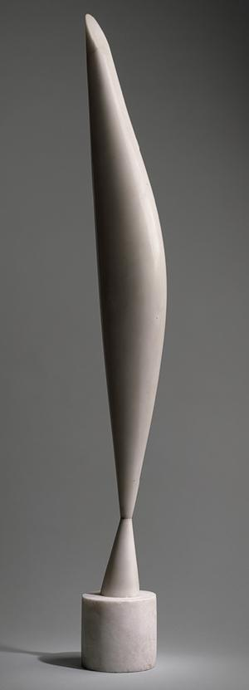
- The Kiss, The Kiss Constantin Brancusi, French (born Romania), 1876-1957 ,1916, Limestone, 23 x 13 1/4 x 10 inches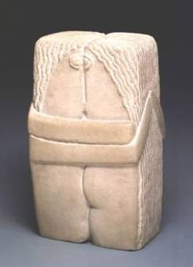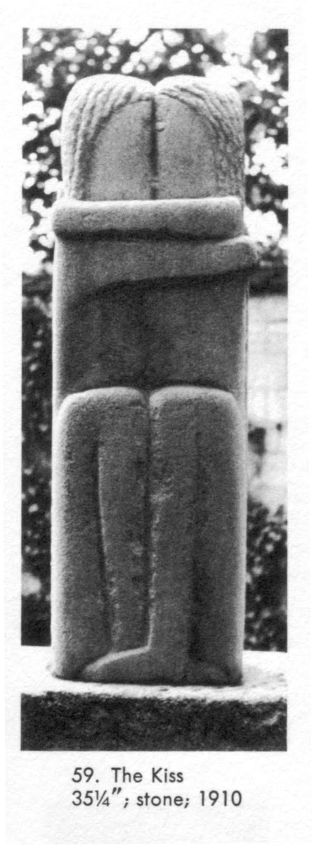
- 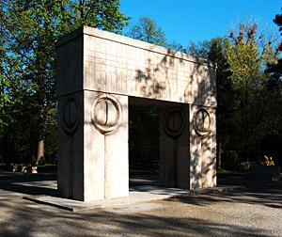It’s significance is very simple: the Kiss Gate makes the transition to another life, and the motif on the pillars stands for the eyes looking inside.

- 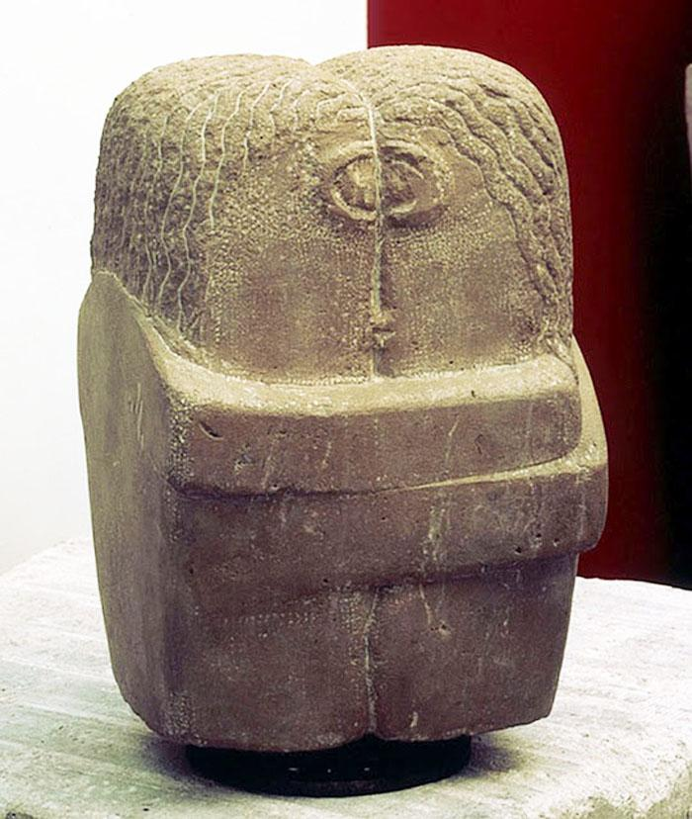1923, stone
- The Gate of Kiss (part of the Sculptural Ensemble in Târgu Jiu) - Constantin Brancusi, 1938
- muse, Share

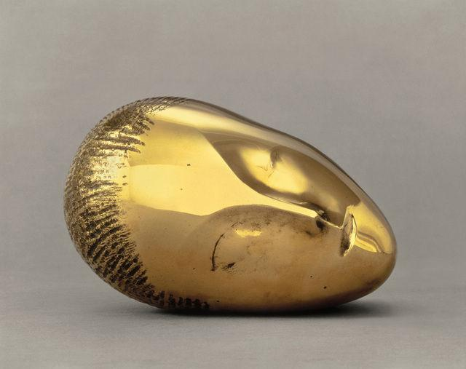

Constantin Brancusi

Sleeping Muse, 1910

Painted bronze

6 ^{3/10} × 9 ^{4/5} × 7 ^{1/10} in

16 × 25 × 18 cm
- CNAC/MNAM/Dist. RMN-Grand Palais / Art Resource, NY / Brancusi, Constantin (1876-1957) © ARS, NY

Musée National d'Art Moderne, Centre Georges Pompidou, Paris
- 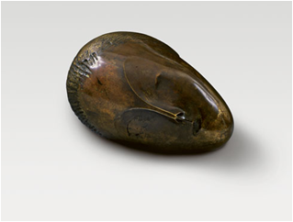1911
- 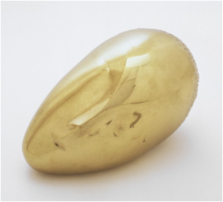1926
- ARTICULATED WALL by Herbert Bayer

Preparation:
(What do you need to prepare for this experience? List steps of preparation in a bulleted format.)
- Make sample piece(s)
  - prepare wood and wire
  - put wire in wood, pull nylon over it
  - two coats of glue
  - two coats of white paint
  - sketches of ideas of paint
  - paint
- Buy / prepare supplies ( 112 students)
  - Nylon: 10 pairs at Walmart for 5.50: 6 packs
  - 12 gage wire (HD: 200ft for 6.25) cut into 2 ft length
  - 2”x4”, cut into squares ( 5 8’ boards)
  - Boards get TWO 12 gage holes drilled in 3/4ths of the way through
- Get presentations ready
  - gather info on artists
  - gather photos
  - put together on PP

Safety:

(Be specific about the safety procedures that need to be addressed with students. List all safety issue in a bulleted format.)
- Do not eat the materials
- Do not throw materials across the room
- If possible, when shaping wire use safety goggles. Otherwise, be very cautious and aware of surroundings. If possible, spread out at the table for maximum space between students so no student accidentally pokes another student with their wire.
- Use newspaper underneath sculpture when painting/gluing
- Use aprons so no paint/glue gets on clothes.
- wash out all paintbrushes/ cups so no glue/paint gets spilled or becomes unusable.

Action to motivate/anticipatory set:
(Describe how you will begin the lesson to stimulate student’s interest. How will you pique their curiosity and make them interested and excited about the lesson? What inquiry questions will you pose? Be specific about what you will say and do to motivate students and get them thinking and ready to participate. Be aware of the varying range of learning styles/intelligences of your students. Some ideas might include: presenting a skit, telling a story, posing a series of questions, role-playing, etc.
1st Day: IS this sculpture abstract or non-objective? If you were the creator, what would you name this piece?
2nd: Is non-objective artwork as important as abstract art?

Ideation/Inquiry:
(Ideation is the creative process of generating, developing, and communicating new ideas, where an idea is understood as a basic element of thought that can be visual, concrete or abstract. List and describe inquiry questions and processes you will engage students in to help them develop ideas and plans for their artwork.)
- Should non-representational sculptures be considered art?
- If an artist intends for a piece to have a certain meaning, but a viewer interprets it differently, which meaning should have more importance?

Procedures: (Align with instructional methodologies and approximate times for instruction.)
Give a detailed account (in bulleted form) of how you will present the lesson logically and sequentially (include approximate time for each activity). Include motivation and ideation/inquiry where appropriate.)
DAY 1:
- Re-introduction of Kaitlyn(2 min)
- Change seats- Maggie ( 8 min)
  - names in a bowl, everyone gets up
  - Maggie or Kaitlyn draws names for each table
  - students sit down
  - whoever isn’t saying names is putting the powerpoint up
- “Bird in Flight” exercises(10 min)
  - Maggie will remind students what ABSTRACT and NON-OBJECTIVE is
  - while Maggie talks, Kaitlyn will pass out index cards and pencils
  - Powerpoint shows first slide: Bird in Space. It does not have the title, only the question is is ABSTRACT or NON-OBJECTIVE
  - Kaitlyn will explain: each student will decide if this piece is abstract or nonobjective and they will write it on their inx card .Below it, they will write their own title.
  - After they have written down on their index card, Kaitlyn will reveal the name “Bird in Flight”
  - Students will discuss with their shoulder partner if this changes that it is abstract or non-objective
- introduction to Brancusi and Abstraction (5 min)
  - Kaitlyn will reveal that it is very abstract- the artist’s intent was to show the movement of a bird.
  - Brancusi is an abstract artist...what does that mean, abstract? He subject that is real, but he simplifies it. He INTENDS for his art to be simplified because he enjoys clean LINES. Look at this piece called the KISS. This picture is the first one he did, but he made this again and again. Would you guess that this one was the first or the last? His subject is two people kissing, and at first he used organic forms but it went more and more geometric. What is organic?What is geometric?
  - The piece we first looked at “Bird in Space” was debated about whether it was art or not because it didn’t look like anything.While the artist intended for the piece to represent movement, it was so abstract viewers had a hard time identify what it was supposed to represent.Now we know that art doesn’t have to be realistic to be interesting. Art that doesn’t represent anything is called what again?
- introduction to David Smith and non-objective -Maggie (5 min)
- reminder of geometric and organic forms- maggie
- TEMPORARY NON-OBJECTIVE Collaborative piece (20 min)
  - Each table gets modeling clay, each person gets an equal piece
  - students will make a GEOMETRIC piece out of their clay
  - at their table, students will combine their geometric pieces to create a sculpture
  - students will deconstruct sculpture
  - repeat with ORGANIC
  - repeat with CHOICE
8. Clean up
Day 2:
- reminder of vocab
  - last week we learned the words ABSTRACT and NON-OBJECTIVE
    - Is this picture abstract or non-objective? why?
    - student who raises hand quietly gets called on
  - we also learned about ORGANIC and GEOMETRIC
    - can I have someone who is QUIETLY AND PATIENTLY raising their hand point out something that ORGANIC shape or form in the room? Is it a shape or form?
    - “ GEOMETRIC?
- show sculpture
  - We will be making these sculptures! They look pretty cool, but they are made of just a block of wood, wire, and nylon!
  - First off, is this piece non-objective or abstract? (student answer)
  - Is it organic or geometric?
3. show quick powerpoint about pieces
- This is some examples of what the end product can look like
- you’ll want to focus on PATTERN
- FORM and color
- while you can do ABSTRACT, this is MUCH MUCH HARDER
- you could choose to challenge yourself to make an abstract, but I would encourage you to make something non-objective.
- We want to get through 3 steps today, so I want you to be focused and safe!

4. shape wire
- I will try to form the wire into something interesting while BEING CAREFUL not to make the wire points go towards my eyes...point them away. I will also be wearing safety goggles or glasses
- Keep the wires ends close together so it will be easy to put in the block
- You can begin, and I will be able to tell if you are ready for the next step when your wire is laid down

5.insert wire
- now I will gently put the wire in the block one at a time
- it may be hard to put in, so gently twist it but be careful
6.put nylon over wire
7. first coat of glue

Day 3:
- Demonstrate what we are doing today: 2nd coat of glue, writing out definitions, doing perspective drawings
- DEFINITIONS: Let’s come up with some definitions for our vocab together. ABSTRACT( represents something, but the artist has changed it), NON-OBJECTIVE (lines, shapes and color- not showing anything REAL life), ORGANIC ( smooth, natural, asymmetrical), Geometric ( hard edge, symmetrical)
- Pass out supplies- helper table passes out sculpture, foam brush, glue while table spreads out newspaper
- 2nd coat of glue: start at the top, pick up your sculpture, cover all sides.
- Fold up newspaper, put sculpture on top of newspaper in center of table.
- Grab sketchbook, divide paper into four, begin writing word, definition, and then drawing an example in the four boxes.
- I SHOW them the ARTICULATE WALL powerpoint…it looks different from different angles! Have them make inferences about what it looks like and how it looks different. Get them to start thinking about how their sculpture is 3D meaning it is seen from multiple sides…so they need to make all sides important.
Day 4:
      - Why is it important to Gesso? ( to get artwork ready to accept paint- clean surface) – quick demo of PICKING up sculpture,
      - Pass out supplies: have newspapers already on table, have helper table pass out sculptures, aprons, foam brushes, and one gesso per table while tables spread out newspaper and put aprons on.
2. First layer of gesso- as soon as they are finished, raised their hand and been approved by a teacher, students will take their sculpture over to the drying table, sit and wait patiently until at least 2/3 of class is finished. Student can work on definition drawings if they have not finished those.
3. Have students come up to the front for a demo on tints and shade ( make sure palettes are ready in the back) Demonstrate how you start with white, lightly mix in the color and white while washing out the brush in between. Colors become solid, then adding a little bit of black. Talk about blending.
4. Leave at least 15 minutes to begin cleaning.
5. dismiss by table to put tint and shade example on the drying wrack, hang apron, wash hands for 10 seconds ( count down from 10).
6. Table helpers use one sink to wash out brushes and palettes.

Day 5:
1. If gesso is thick enough, one layer is enough. But if not, one more layer and another week to dry.
2.If no gesso layer is needed, have them choose their favorite PLAN and begin painting
3. NEED: additional work while gesso is drying
Day 6:
work day
reflection

Student reflective/inquiry activity:
(Sample questions and activities [i.e. games, gallery walk, artist statement, interview] intended to promote deeper thinking, reflection and refined understandings precisely related to the grade level expectations. How will students reflect on their learning? A participatory activity that includes students in finding meaning, inquiring about materials and techniques and reflecting about their experience as it relates to objectives, standards and grade level expectations of the lesson.)
  - Document Cam: Ms. Murphy will take students out one by one and video tape responses to several questions questions:
    - What is your name, and what is the name of your piece?
    - Is your piece abstract or non-objective? why?
    - Is your piece geometric or organic? how do you know?
    - what was one thing you learned by doing this project?
    - if you were to do this again, what would you do differently?
    - what was your ARTISTIC INTENT
While students are doing the document cam, students are making a name plate with the title of the piece and their name on matte board and putting it on their piece or finishing their piece.

Post-Assessment (teacher-centered/objectives as questions):  (Have students achieved the objectives and grade level expectations specified in your lesson plan?) | Post-Assessment Instrument:  (How well have students achieved the objectives and grade level expectations specified in your lesson plan? Rubric, checklist, rating scale, etc.)
- You can tell the difference between ABSTRACTION and NON-OBJECTIVE art  - You can show me a GEOMETRIC and ORGANIC form  - You know that artists like BRANCUSI and SMITH have artistic INTENT  - You can collaborate with your table to create a TEMPORARY NON-OBJECTIVE sculpture  - You can make your own Non-objective OR Abstract sculpture using nylon, wire, wood, glue and paint!  - You can talk about your work and your personal artistic intent | Advanced + Proficient * Developing *- Basic -  Demonstrate knowledge of characters and expressive features of art clearly demonstrate geometric and organic form in warm up, discussed and identified both non-objective and abstract art, and used art terms in artist statement. demonstrate geometric and organic form in warm up, identified some non-objective and abstract art, and used some(3-2) art terms in artist statement. attempted geometric and organic form in warm up, identified a few non-objective and abstract art, and used one art term in artist statement. did not demonstrate geometric and organic form in warm up, could not identify non-objective and abstract art, and used no art terms in artist statement.  Create a sculpture that demonstrates knowledge of form, color, and pattern. Piece fully covered in paint, color carefully considered, patterns express understanding of form. Piece covered in paint, color and pattern evident but only express some understanding/response to form Piece mostly covered, color and pattern do not respond to form. Piece lacking coverage, color and pattern not planned nor relating to form at all.  Demonstrate artistic intent by planning, discussing in groups and in documentation Identifies artistic intent in brancusi and smith, creates personal artistic intent by planning and documenting planning in sketchbook, doc cam discussion clearly identifies artistic intent, class can identify artistic intent of artist creates personal artistic intent by planning and documenting planning in sketchbook (2-3), doc cam discussion clearly identifies artistic intent, teacher/artist helps class identify artistic intent of artist creates personal artistic intent by planning and documenting planning in sketchbook (only 1-2 ideas), doc cam discussion identifies some artistic intent, class cannot identify artistic intent of artist artistic intent not planned out or demonstrated in sketchbook, doc cam, or discussed.  Effort highly focused and in “studio” during work time, always on task and attentive during instruction mostly focused and in “studio” during work time, usually on task and attentive during instruction sometimes focused and in “studio” during work time, sometimes on task and attentive during instruction not focused and in “studio” during work time,off task and in-attentive during instruction  Studio Habits Clearly and always exhibited Clearly and mostly exhibited Somewhat and not consistently exhibited Not exhibited

Self-Reflection:
After the lesson is concluded write a brief reflection of what went well, what surprised you, and what you would do differently. Specifically address: (1) To what extent were lesson objectives achieved? (Utilize assessment data to justify your level of achievement.) (2) What changes, omissions, or additions to the lesson would you make if you were to teach again? (3)What do you envision for the next lesson? (Continued practice, reteach content, etc.)

