Kaitlyn Birdsall

Course HIST 492 sec 002, How to Be an Emperor, Prof. Didier

12/17/2010

***Zen Buddhism in Samurai Society demonstrated through Aesthetics of the Tea Ceremony***

Image courtesy of http://www.visitjapannow.com/appreciating-the-japanese-tea-ceremony

**The Wabi Sabi Warrior:**

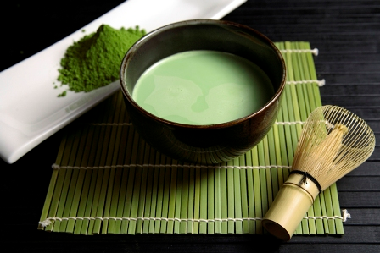

“Zen seeks the awakening by which one becomes a Buddha in this very life. By stilling the mind and overcoming the dualism of subject/object apprehension of the world, one breaks through the scrim of the names and descriptive world of normal consciousness. In a moment of radical realization (satori or kensho) all things become clean and “en-lightened” with the light of perfected wisdom- not the wisdom of words but the wisdom that grows out of the experience of emptiness (ku). To attain and to live this wisdom in everyday life is enlightenment and being a buddha.”[1]

Zen Buddhism focuses on the inner life, finding enlightenment through meditative practices, which can come from everyday routine. [2] It has always been, and always will be, a religion portrayed as peaceful, compassionate, and non-violent. So how is it that such a peaceful religion became associated with and promoted by the most violent, fierce warrior elite in Japan?

Samurai, the feudal warriors that prevailed in Japan for centuries, were portrayed as a brutal yet loyal class. Swearing fealty to their feudal lord, samurai would go to whatever measures to bring honor to their lord’s clan and thus themselves. They were “first and foremost a ready-for-combat warrior at all times in all circumstances,” and their fierce pride meant they were not afraid of death. [3] If he was somehow dishonored, a samurai would face death by his own hands in a bloody ritual suicide called *seppuku,* to preserve his dignity.[4] As time passed on, samurai became the cultural apex which formed Japanese society, not only influencing the government, but the arts and religion as well.

Zen Buddhism was not only promoted in Japan by samurai, but concepts of Zen aesthetics were developed through samurai tastes. While art and aesthetics have been intertwined with every major religion, “perhaps only in Japan has aesthetic experience been so overtly related to religious experience and to artistic pursuits themselves been so self-consciously thought of as ‘ways’ of religious significance.”[5] Zen perception combined with samurai ideals formed a new aesthetic quality that became the center of Japanese culture from the Kamakura Period (1185 to 1333) to today. While there is no denying the bloody history of the samurai, they helped shape Zen and the aesthetic concepts associated with Zen in Japan, and Zen had its own part in shaping the samurai belief system. The illustration of these two cultures intertwining is no better seen than in the Japanese ritual that was the highlight of high culture: *Cha-no-yu*, or the Way of the Tea. The tea ceremony consisted of a few guests sitting in a small, simple tea room, while a tea master or practitioner served them tea in specified tea bowls in a highly ritualistic way. While it at first appears to a western mind as a simple ceremony, its history is the story of two seemingly different societies coming together to form the culture of Japan.

The similarities between samurai ethos and Zen Buddhism have culminated to create the aesthetics found in the Japanese tea ceremony as demonstrated by the ceramics used in the ritual. While the idea of tea as a part of Zen ritual came over from China, the tea ceremony evolved into a Japanese ritual through the influence of samurai and Zen followers and their mutual value of discipline, concepts of the self, and the aesthetics of austerity, or *wabi* and rusticity, or *sabi.*

**ORIGINS**:

To understand the similarities of samurai and Zen aesthetics, one must understand where Zen came from. Zen originated in China and not Japan, but the samurai applied and interpreted it in a new way that allowed for them to adopt it as their religion.

The monk founder of Zen in Japan helped establish the initial connection of Zen and the samurai by introducing this sect of Buddhism. Eisai (1141-1215) was a Tendai monk who traveled to China on two different occasions because of his interest in Zen (Ch’an) Buddhism and renewing the Buddhist faith in Japan. [6] The Japanese had separated themselves from the cultures of mainland China from 894 to the mid-twelfth century and thus had long been separated from the ‘original’ Buddhist concepts. [7] Japanese Buddhist monks were hungry for power, controlling through force and failing to reflect the compassion expected of Buddhism. The temple at Enryakuji on Mt. Hiei had trained militant monks called *sohei* who were used to make demands on the government, defining Japanese Buddhism of the day as a highly ritualized, luxurious religion based on wealth.[8] It was understandable that Eisai would want to become reacquainted with Chinese Buddhism, and in doing so he discovered the Chinese Ch’an Buddhism that was based on meditation. Becoming a Ch’an Renzai master, he established a Zen temple in Kyoto and was eventually supported by the shogunate of Minamoto Yorimoto. [9]

While Eisai always promoted Zen as an extension of Tendai Buddhism, Zen soon became established as its own sect. It was more applicable to the common people due to the way that Zen was practiced through meditation and was not reliant on scriptures. Thus, they did not have to lead a monk’s life to find salvation. However, Zen did not begin as a popular religion in Japan. Shunned by other Buddhist sects, and fighting for popularity amongst other sects such as the Pure Land Amida and Lotus schools, it was just one of many.[10] It did not catch on in popularity until the Kamakura warrior-rulers adopted it as their religion so as to give them some cultural credentials.[11] This warrior society saw Zen as a viable religion because of its similar concepts of discipline and simplicity. Samurai could understand its discipline and repetitive practice as a way to reach enlightenment because they themselves used discipline and repetition to hone their warrior skills. In the end, samurai would not merely find it a religion that they could understand and apply, but would use it as the means to creating a new culture that was strictly Japanese.

Eisai was not only responsible for bringing Zen to Japan but also for introducing the notion of tea, which the samurai and monks later developed into the tea ceremony. Eisai encouraged meditation while drinking a whisked green tea called *matcha* to help keep those meditating alert[12]. This was not his own original idea but in fact another that he borrowed from the Chinese Ch’an sect. The original Ch’an masters believed that enlightenment could be reached while doing such “everyday activities as cutting firewood, heating bath water, tilling the fields, or sweeping the monastery floors.”[13]

2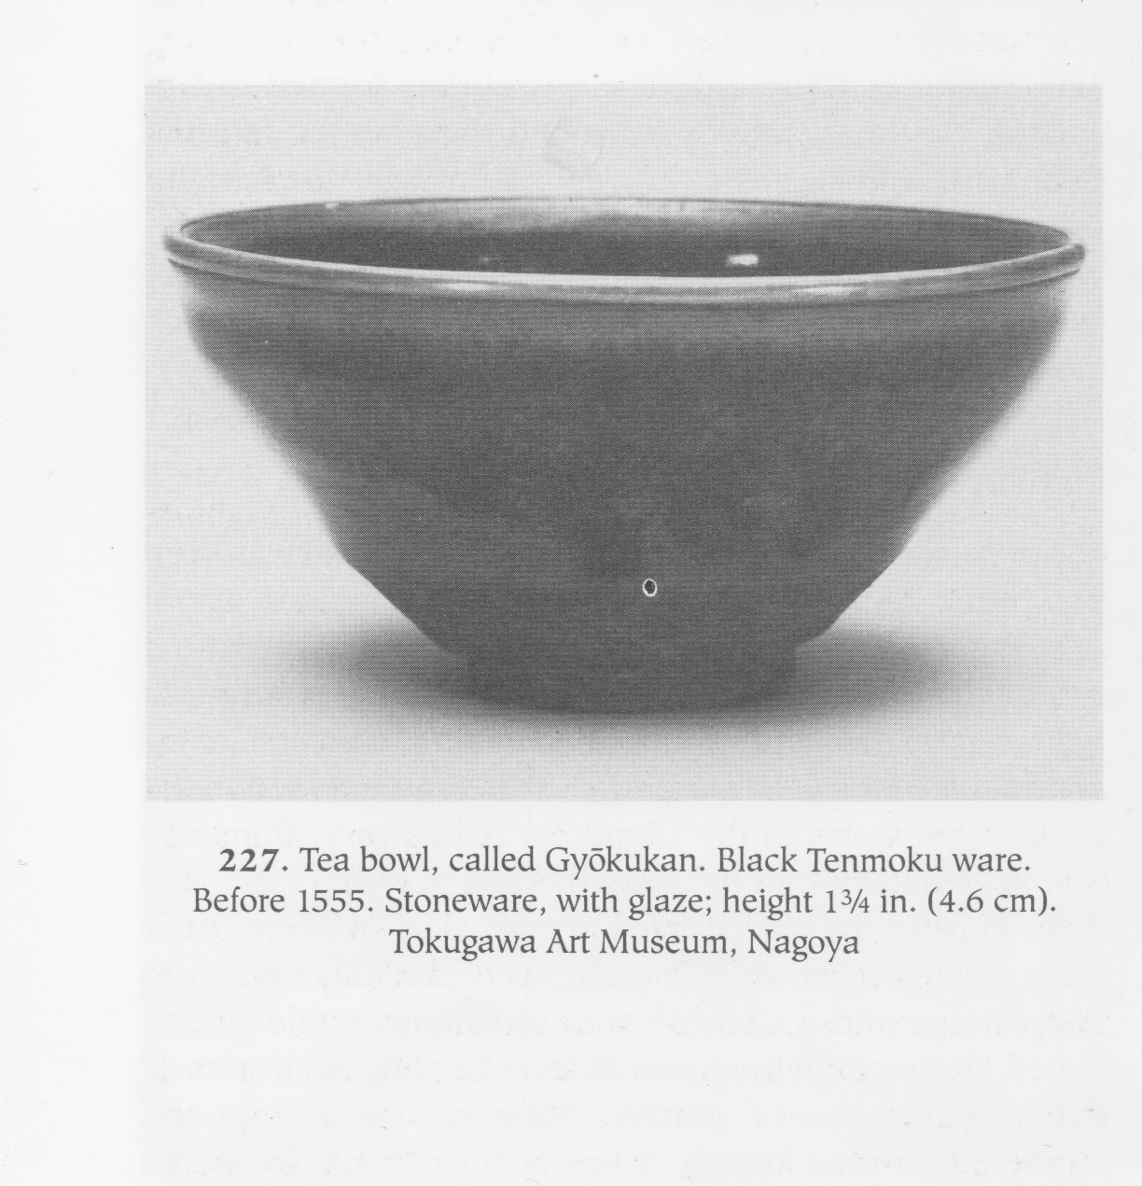

Tea Bowl, called Gyoukukan. Black Tenmoku ware. Before 1555. Stoneware, with glaze; height 1 ¾ in. (4.6 cm). Tokugawa Art Museum, Nagoya.

1

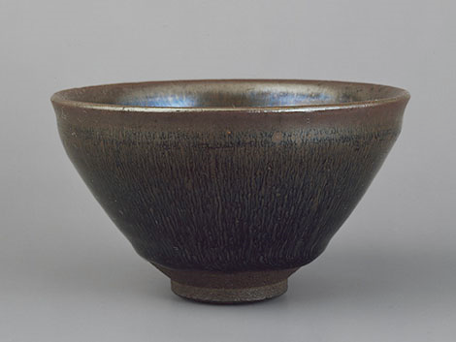

Song dynasty, 960-1279; Jian ware  
Fujian Province, China  
Stoneware with hare's-fur glaze   
Diam. 5 in. (12.7 cm)

image by: <http://arts.cultural-china.com/en/31Arts4401.html>

Chinese Ch’an expressed the idea of simplistic everyday life through its art forms. One such minimalistic art form was a painting style called “one-corner,” in which artists would attempt to represent form in the least amount of brush strokes possible.[14] It was not only paintings that the Chinese imbued Zen ideals into, but also into ceramics. Tea bowls originally used by the Ch’an priests in the Song Dynasty (960 to 1279) were made in the *Jian* style and held the aura of “simplicity and understated elegance” by using a simple black or brown iron glaze (See image 1).[15] Japanese Zen potters sought to copy these forms for their simple beauty and began making *Tenmoku* ware (see image 2), named after the Chinese Mount Tianmu, where the Zen monastery was that began this use of drinking tea. The direct copy of this art form reflects the Chinese influence on Japanese Zen aesthetics from the very beginning.[16] However, the connection between samurai society and the elaborate tea ceremony was yet to come, for the bowls illustrated above are from the beginning when samurai were just starting their long partnership with Zen.

Chinese influence on Japan is made evident by the concepts of Zen and Zen aesthetics entering into the country through the use of copied ceramics. However, this is only the beginning of a long story of how the samurai were able to use this Chinese religion and form it into the cultural forge it became.

**DISCIPLINE**

Samurai have always been depicted as the unstoppable warrior who would go into battle to protect his lord’s honor, not seeming to care about life lost. In fact, samurai seem to base their entire life on death, as explained by Lord [Nabeshima] Naoshige (1538-1618):

Bushido comes down to death. Even tens of people cannot kill such a person. Great things cannot be achieved by [merely] being earnest. A man must become a fanatic to extreme of being obsessed by death…The martial arts require only an obsession with death. Both loyalty and filial piety (the two other major samurai virtues) are included within this. [17]

The term *bushido* that is referred to above is the samurai code of ethics and chivalry. While it was not truly written down until the Tokugawa age, a time of peace, it focuses on the discipline and practice required to be the ever-ready warrior who hones his skills and is always ready for death. This masculine discipline required in the samurai way of life mirrored Zen practice, and with this culmination of disciplines, the ritual of the way of the tea was formed.

Zen monks focused on a meditative, practical and simple life that was ruled by discipline, one that reflected the samurai lifestyle. This meant that it was appealing to samurai because it was already familiar in their belief system. To live the ideal life, both samurai and monk were expected to live meager lives, taking only enough to survive, and never complaining in any situation. Samurai dedicated their lives to their lords, and would only live off of what their lord gave them. Monks dedicated their lives to meditation and the temple in order to find enlightenment, and would only take what they received.

They may have lived meager lives, but they also had an amount of pride and dedication that was vital to their way of life. It truly struck a chord during the Kamakura period, when samurai wanted to separate themselves from the traditional luxurious lifestyle of the court and their deeply embedded rich Buddhist rituals.[18] Kamakura samurai, lead by Minamoto no Yorimoto (1148-1199), overthrew a corrupt, luxurious aristocracy and needed a religion that supported samurai way of life, which they found it in Zen.

Zen required a discipline that was focused on the daily rituals of life, which related to samurai. While many Buddhist sects used ritualistic chanting of sutras in attempt to discover enlightenment, Zen did not focus on doctrine, because “words or characters can never adequately express religious truth, which can only be realized by the mind.”[19] Words are detached from reality because they go through so many levels of people and often are misconstrued.[20] Zen followers desire to understand the thing itself, not the misconstrued empty words that are so far from the thing itself. The tangible practice of everyday life thus became their ‘sutra,’ which made it so applicable to samurai life. Their life was ruled by practicing and honing their skills, and this discipline of the warrior was very much the reality of Zen.

Samurai and Zen monks’ lifestyle were also similar in the ways they presented themselves because of their disciplined means. Both were quite proud, exerting themselves as dignified and manly almost to the point of being rude. [21] Each would stick up for their belief structure, and considered honor and their way of life more important than comfort and luxuries. Adepts of both would rather face death head on rather than run away in a cowardly manner. Endurance and restricted lifestyles let the samurai and the monks lead more focused lives. Monks and samurai had to find other reasons to live other than for monetary gain, and thus their hard, disciplined life became a source of pride.

The samurai also found Zen’s use of any discipline as a way towards enlightenment something both appealing and necessary. Samurai had to live a warrior lifestyle that was dedicated to their art and their lord, and thus they would not be able to live the life of a monk. But with so many of the ethics reflecting each other, Zen and samurai lifestyle seemed made for each other. While other Buddhist sects would expect either a monastic life, or a ritualistic courtly life, “Zen’s broadminded acceptance of almost any true discipline as an aid to enlightenment, and its belief in the power of the intuitive soul, gave a spiritual basis to the samurai’s single-minded pursuit of skills in swordplay and archery.”[22] This allowed for samurai to find *satori* in the practice of weaponry, nearly leading the life of a Zen ‘warrior monk.’

Zen followers believed in practicing to the point of automatic reactions, making their practices easily applicable to martial arts. Zen sharpens the mind through practiced discipline, and a “swordsman’s training was geared to making his techniques fully, unthinkingly automatic.”[23] An automatic reaction meant that it became a bodily instinct, allowing a samurai to be separated from the action. Thus it separated the samurai from a bloody act, and was considered a natural reaction that did not come from the consciousness. Through the application of this Zen concept of separating the conscious from the action, a samurai was no longer committing an uncompassionate act, and could fully and completely follow the Zen religion. The act of killing was now considered a natural reaction unconnected to consciously acting out of anger, and was now considered “the life-giving sword.”[24] This automatic reaction would eventually have a part in the tea ceremony as well.

The formation of the tea ceremony was also based on the disciplinary practice of Zen and samurai. In an attempt to create a display of cultural power and influence without showing the luxury of the old court, the tea ceremony began being formed in the Kamakura period. It began in this period as a way for the new class of aristocracy, the samurai, to display wealth in a way that still reflected the frugal lifestyle. Tea tasting parties became a way to express status. However, it was not until Murata Shukò (1423-1502), a steward monk who became one of the first tea masters, and his later predecessor, Sen no Rikyu(1522-1591), that a true tea ceremony discipline was formed that required practice and ritual only perfected through repetition. [25]

Just as samurai and Zen followers believed in practicing until a form became automatic, tea practitioners would perform the simple movements associated with the making of tea until it became routine. This automatic discipline was beautiful and fluid, allowing for the meditative “nothingness,” or dissociation to the action, to come in to play. In relation to the tea ceremony, the true tea masters could practice and make the slightest simple moves into a fluid beautiful movement, only because of routine practice.

Zen’s acceptance of all forms of discipline gave it a strong connection to art. Zen found that the “discipline and practice of artistic creativity made art a natural ally of meditation itself. For Zen the arts were ‘ways” of spiritual significance, especially as practiced with a Zen context.”[26] Thus, while the tea ceremony was first used for meditative purposes, the addition of art in the tea ceremony was almost a necessity. Ceramics used in the tea ceremony had to reflect the manly, disciplined lifestyle characteristic of Zen monastic life, so similar to the samurai lifestyle. One style that reflected the rugged, disciplined lifestyle of the samurai was the Raku ware. Raku is easily relatable to the samurai lifestyle, not only because of its Japanese origins, but for its very presence. Raku ware is made thick so that it can retain the heat of the tea, but not be hot to the touch.[27] Its deep, rugged look and useful form reflect the meager, strict and disciplined life of the samurai. Raku is a low-fire glaze, maturing over time. The amount of time the bowl is in the kiln changes the entire appearance of the bowl, almost like the repetitive practice that eventually leads to that ‘ah-hah’ moment of enlightenment. It is the ultimate form of Japanese stoic pottery, perfect as an example of how the samurai wanted to be portrayed.

**3. Teabowl named *Hòrinji***

By Raku Choujirou (1516-92)

Raku pottery with black glaze;H.89 mm

Published: Urasenke foundation 1985, pl 26

Lent by the Urasenke Foundation, Kyoto

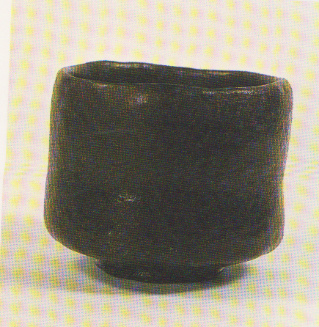

**THE SELF**

“ The Great master Dogen Xenji (1200-1253) said: ‘To study the Buddha is to study your own self. TO study your own self is to forget yourself. To forget yourself is to have the objective [phenomenal] world prevail [intimately] in you. To have the objective world prevail in you is to let go of your ‘own’ body and mind as well as the body and mind of ‘others’. The enlightenment thus attained may seem to come to an end, but…[it] should be prolonged and prolonged.”[28]

The samurai life was not centered on himself, but others. Dedicated to his warrior art and most importantly to his lord and clan, a samurai’s life seems to lack the sense of individual gain. The Zen monks lived a similar life to the samurai. Buddhist monks would live together in a shrine, giving up their lives to be part of Buddha. Both samurai and Zen monks appeared to live lives dedicated wholly to others without thought of the self. However, both of these images are incorrect, for both samurai and Zen monks sought to find an inner enlightenment through individual and internal means. Through a Zen lens, samurai sought “not to USE the sword, but to BE the sword …Everything was sought in the soul, as a means of freeing though from the fetters in which all forms of knowledge tended to enchain it.[29]Zen’s use of looking inward instead of relying on outside sources resonated with samurai society, and as samurai absorbed this concept of Zen into their culture, the idea of a simplistic and private tea ceremony was born.

Samurai followed a path that focused on the central core of the body –the stomach –so as to strengthen all areas of study. To a samurai,

The expansion and intensification of the sensory and intellectual awareness and activity is centrifugal –it leads to the scattering and dissipation of life-energy; but the concentration of one’s basic life force is centripetal and strengthens one’s vital energy…(through) an inwardly directed focusing of one’s energy.[30]

This internal focus allowed a samurai to be one with his sword, to have control over his emotions and not let those emotions affect his actions. Some samurai gained a specific ‘sword philosophy,’ developing a concept of the “life-giving sword.” Kintayu Hori (1688-1756) coined this term, using Zen philosophy to describe ceasing to be:

Your own conscious master, but become an instrument of the unknown. The unknown has no ego-consciousness and consequently no thought of winning the contest, because it moves at the level of non-duality, where there is neither subject nor object.[31]

This meant that the sword was but an extension, and the swordsman was no longer connected to life and death, but instead he followed his center, his instinctive response. Without feelings or attachment, the sword was meant to provide life as a protector against those who would destroy it. An enemy would thus be the one who came against the sword, and lost. This concept of a centered, self-controlled swordsman unconnected to emotion echoes concepts of Zen.

Zen also focuses on a central perception. One Zen saying is “the One in the Many and the Many in the One…the One remaining as one in the Many individually and collectively.”[32] Contrary to Western ideals of individuality, the Zen concept of awareness of self carries with it an idea of solitude in the masses and finding peace and tranquility inwards. It is not the case that Zen followers focus on standing out of the crowd or being better and more individual to gain personal praise, which is similar to a Western idea of the self. It is an understanding of the self and the finding of enlightenment through personal interpretation, not through chanting in mass with other monks. It is a self awareness that was in tune with the samurai way of thought.

While samurai and Zen focused on internal tranquility and were forming a bond with each other, the country itself was attempting to gain internal peace. As Japan entered the Momoyama period( 1573-1615), soon after the Warring States Period, the warrior leader Oda Nobunaga(1534-1582) rose to power and was able to unite Japan. A brutal leader, he slaughtered the entire Enryaku-ji Tendai temple because of their opposition to his rule. Instead of supporting the old Buddhist ways, Nobunaga supported the new Portuguese Jesuit missionaries (1543)[33] and was not afraid to slaughter any Buddhist temple that stood in his way. Due to Zen’s universal acceptance of different disciplines and its focus on improving internally as opposed to seeking exterior gain such as wealth, Nobunaga did not oppose Zen believers. Eventually, the Zen tea ceremony became intriguing to Nobunaga and later his predecessor, Toyotomi Hideyoshi(1536-1598), both of whom became adamant supports of the ritual. Nobunaga’s interest in the ceremony came about because of the great tea master, Sen No Rikyu(1522-1591).

The Tea Ceremony (or *Cha-no-yu*) that is still practiced today was perfected by the great tea master Rikyu, who truly began combining aesthetic taste and the drinking of tea, forming a ritual that was intended to help partakers look internally and perfect themselves. The influence of the tea ceremony was begun during the time of the Kamakura and Ashikaga shogunates( 1336-1573), but it was not until the time of Nobunaga and Hideyoshi that Rikyu articulate the ritual as a Zen practice.[34] It was a culmination of the Chinese Zen philosophies, but also included Japanese aesthetics from samurai and Shinto cultures. With all its influences, the Tea Ceremony was intended to help in meditation, a type of cleansing of the soul. It is a ceremony that celebrates the nature of things and returning to a simpler time. The four elements that the ceremony embodied were “harmony (wa), “reverence”(kei), “purity” (sei) and “Tranquillity” (jaku).[35]Most importantly, the tea ceremony was about the self and applying these aspects of harmony, reverence, purity and tranquility internally. A tea master had to be utterly aware of all aspects of the tea so as to make every movement pleasing to both the master and the receiver. It was a practice of self-discipline and an awareness of all surroundings so as to find one’s inner tranquility.

Sen no Rikyu’s influence on the tea ceremony did not stop at forming the rituals and practices, but also formed the concept of beauty in the blemished and tarnished and a love of Japanese things. This is most prevalent in viewing Raku pottery, especially seeing how Raku pottery developed.

The name *raku* is translated as pleasure, and was thus named by Sen no Rikyu in relation to Hideyoshi’s Jurakudai Palace, where the tile-maker Chojiro was commissioned to first create raku ware. [36] One way in which Raku ware demonstrates aspects of Zen and samurai concepts of the self is in the way that it is formed. Once raku ceramics have been fired in a low temperature kiln, it is taken out while it is still hot and introduced to other elements such as cold water, grass or straw, or just cool air.[37] This process means that the potter has no control of the outcome, and is therefore disconnected with the action of the finishing touches of the ceramic. The creation of the ceramic and the ‘ah-hah’ moments when a potter discovers his work has succeeded relates directly to Zen enlightenment and the ‘ah-hah’ moment when a follower reaches *satori* through the separation of the internal conscious to the everyday meditative action.

4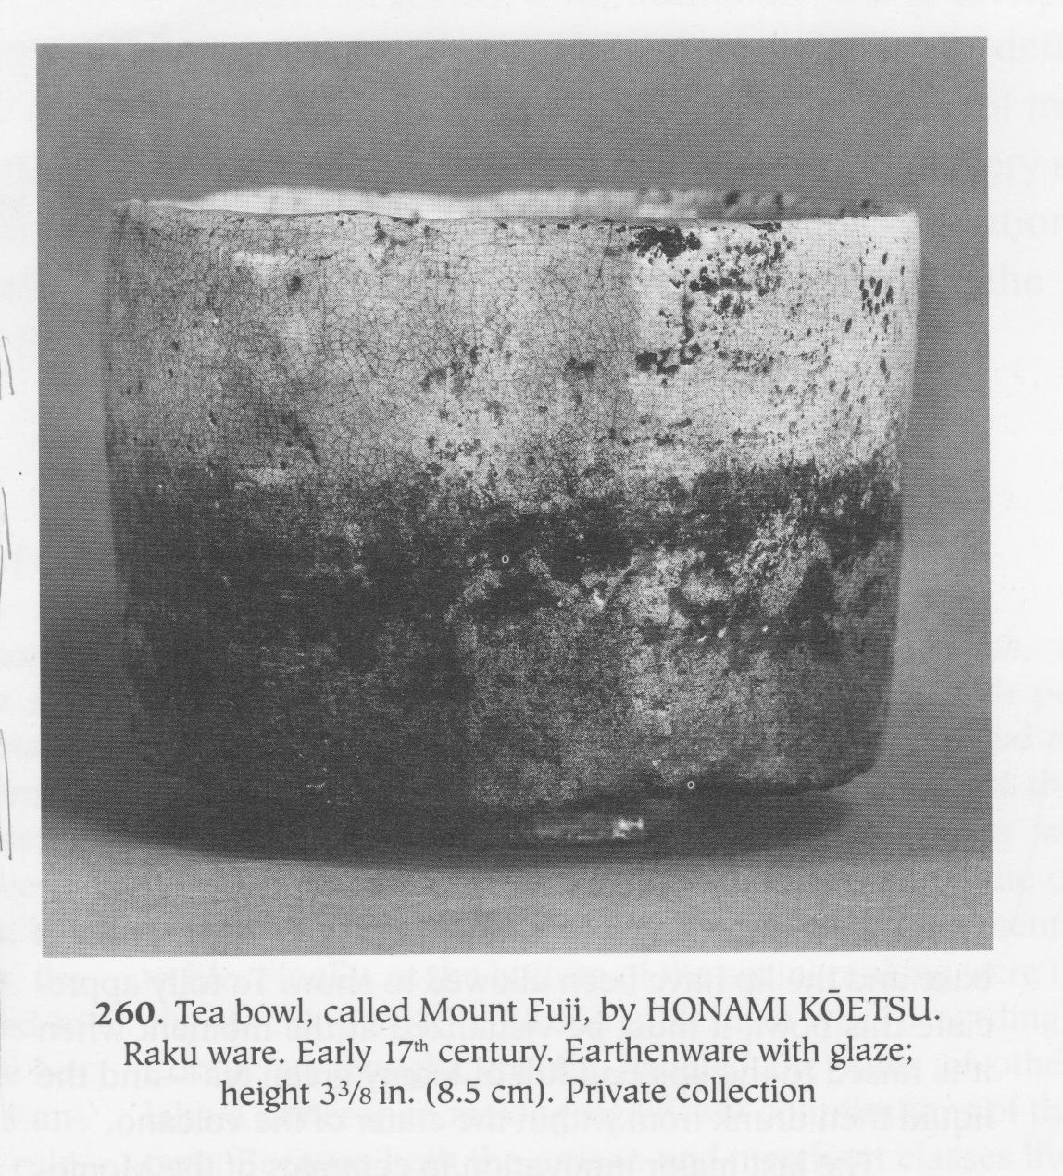

Raku ware also demonstrated concepts of the self through its individuality. Because each pot was handmade and was introduced to unpredictable elements, no two ceramics look alike. It was made by the Japanese in Japanese kilns, and demonstrated Japanese concepts of beauty. Because of the unique characteristics and importance of each tea bowl, many ceramics were given names by their owner. The names chosen could reflect a person or place that the owner felt a close bond with or a moment of enlightenment that was associated with that person, place or thing. Take for example, this tea bowl named after Mount Fuji –an iconic image of Japan with so many interpretations. Japanese tea bowls were cherished objects that were not only instruments in the tea ceremony, but a reflection of the owner’s internal triumph –his pleasure.

The tea ceremony and the type of pottery used helped transcend the concepts of the self in order to find inner tranquility, a concept that was both valued and sought by samurai and Zen followers.

**SIMPLICITY (WABI)**

Reflecting the asceticism of the samurai ethic, the Buddhist saint strives to be diligent about his work, yet indifferent to wealth. In no instants do the saints countenance ‘money grubbing’ or the spirit of ‘acquisitive individualism.’[38]

While the tea ceremony became a symbol of power and wealth, it depicted the ideals of the simple life the samurai and Zen monks. Oddly enough, a ceremony created so as give the newly developed samurai society cultural dignity had the main theme of celebrating poverty. This concept was perhaps the most important to Zen, samurai and the development of *Chan-no-yu*. The related concepts of celebrated poverty in both samurai and Zen culture allowed for the creation of a Japanese aesthetic called *wabi,* or beauty in the austere and imperfect.

The concept of *wabi* was a development of both samurai and Zen culture, but *wabi* is not easily defined. Author D. T. Suzuki describes *wabi*:

To be poor, that is, not to be dependent on things worldly –wealth, power, and reputation –and yet to feel inwardly the presence of something of the highest value, above time and social position.[39]

As described in previous sections, samurai ideally lived a life where wealth was not the ultimate objective. Zen priests had these same ideals, living with very little because they did not want the matter of wealth to get in the way of reaching enlightenment. To a Zen monk, material possession meant attachment, and because of that connection to a worldly thing, one could not be a truly free spirit[40]. While some aspects of the tea ceremony did lead to the value of objects, especially that of tea bowls, the intention for the ceremony was for the participants to be separated from concepts of wealth.

Wabi is most easily relatable as an aesthetic form found in pottery. Because it was favored by Rikyu, wabi aesthetics are found in almost all aspects of the tea ceremony, from the quaint tea hut, the small amount of tatami mats, to the very tools used to perform the ceremony. Sen no Rikyu describes the concepts of wabi behind the tea ceremony very eloquently in the text *Namporoku:*

*Chanoyu* of the small tea room is first of all a Buddhist spiritual practice for attaining the way. To be concerned about the quality of the dwelling in which you serve tea or the flavore of the food served with it is to emphasize the mundane. It is sufficient if the dwelling one uses does not leak water and the food served suffices to stave off hunger. This is in accordance with the teachings of Buddha and is the essence of *chanoyu.[41]*

5

Chawan tea bowls were made with many blemishes because of their rough handmade quality, but these inaccuracies were the celebrated parts of the piece. Asymmetry was the key, and the trained eye could see the blemishes and appreciate the bowl’s exemplification of a return to nature and simplicity. Rikyu also promoted Japanese made pottery, and while inspiration may have been found in Chinese and Korean ware, the Japanese style ceramics used in the tea ceremony had the unique Japanese charm of celebrating simplicity and asymmetry. Take for example this Shino ware, characterized by its simple decoration inspired by nature, and thick white glaze that naturally bubbles to create unique form. Shino ware was being developed at the same time as other forms of Raku ceramics, but differed in several ways from other Raku. Like many types of pottery that developed for the taste of tea, Shino ware was from a specific province of Japan, the Mino Province[42]; as Rikyu desired, the art form of pottery for the tea ceremony was being developed by the Japanese to be admired by the Japanese. It is simple and blemished, but “simplicity in form does not always mean triviality of content.”[43] It differs from earlier Raku ware because Shino has a lighter, often white glaze, which allows for the low firing temperature to change the color of the pigment in a natural way. Shino ware embodies the aesthetic of *wabi* because of its blemished asymmetrical form, and its reflection of nature in both the small decoration depicting natural elements and the natural change of pigment from the low fire glaze.

The celebration of poverty that was shared by the samurai and Zen enthusiasts allowed for the formation of the *wabi* aesthetic. Through the use of simple, austere and blemished tools, practitioners of the tea ceremony were able to relate it back to the meditative practices of Zen. Tea bowls that held *wabi* characteristics were valued for their blemishes, not because they represented wealth but because they represented a detachment from wealth.

**RUSTIC (SABI)**

Another aesthetic quality that goes hand in hand with *wabi* is that of *sabi,* literally derived from the Japanese word meaning ‘rust[44].’ It is the appreciation of things that are worn with age, that have been used over and over again, that have fallen into decay or obscurity. *Sabi* covers the tangible and is thus easier to understand as an aesthetic taste. However, it is not merely an appreciation for something that is old, but something much more. Both Zen and samurai cultures appreciated worn objects, and this appreciation led to the development of *sabi* aesthetics in the tea ceremony.

Zen followers developed the aesthetic of *sabi* due to their concept of unattachment. *Sabi* is a sign that things are fleeting, and that time is passing, and thus the moment must not be held on to. The brief and tangible become a sad but beautiful thing to be appreciated. The following poem gives an understanding of *sabi*:

The yomogi herbs in the garden

Are beginning to wither from below;

Autumn is deepening,

Its colors are fading;

Not knowing why, my heart is filled with melancholy.[45]

The poem describes the fleeting moment as a plant withers as winter descends, but while the heart is sad, the decay is still appreciated. It is small, and just a moment, but poignant. The author must have been very aware of nature and of himself to appreciate it, but also very distant from the object being described, appreciating it from an aesthetic viewpoint. Because Zen seeks detachment, objects that describe time passing express why exactly adepts must not be attached to material things. Once again, it comes down to honorable poverty.

Samurai promotion of *sabi* is due to their appreciation of poverty as well. Something that has been passed down, that has been used, that has developed that ancient patina reflect the matured samurai, one who has practiced his skills continually so as to be the retainer of his lord. It supports samurai concept of honorable poverty, for “the samurai would rather starve than to live by some expedient unworthy of his dignity.”[46] This near-obsession with living in simplistic poverty mirrored Zen, and samurai began living similarly to Zen monks. Such is the case with Toki-yori (1247-1263), who was the warrior governor leading the country and who entered monastic life, living in a rustic old hut:

Higher than its bank the rivulet flows;

Greener than moss tiny grass grows.

No one call at my humble cottage on the rock,

But the gate by itself opens to the Wind’s knock.[47]

A samurai leader could become a monk, but still maintain samurai skills. By living in abject poverty, celebrating life’s transience, and drawing closer to nature, a samurai used Zen concepts to draw closer to the idea of the perfect samurai warrior. All of these concepts were played out in the tea ceremony.

The tea ceremony reflected *sabi* aesthetics through the environment and objects used in the ceremony. The concept of a humble, dilapidated hut as the meeting place of the ceremony symbolized not only the honor found in poverty but also the fleeting feeling of time passing. Tea practitioners showed their appreciation for the fleetingness of time by using ancient and worn tools that had history and showed its age. In this way, ceramics that were well loved and passed on as heirlooms became more and more valued because of the history associated with them, and the physical display of the ceramics aging. However, not all ceramics that brought feelings of *sabi* were truly ancient. Some potters attempted to copy characteristics of the aged and worn look, purposefully allowing pieces to weather. While this ‘fake’ *sabi* seems to detract from the original concept, to a Zen tea enthusiast whether the object is truly aged or it has the appearance of age gives the same emotive quality of fleeting time, and thus accomplishes the point of *sabi.* This particular piece is a tea caddy used to store *matcha* for the ceremony, but it was cherished because of its natural rustic look. It was formed with natural blemishes, and grew more rugged with age. While Rikyu appreciated this particular piece because of the naturally worn look, it grew to even greater importance because of its continued use and historical significance. It is a piece that shows the passage of time.

6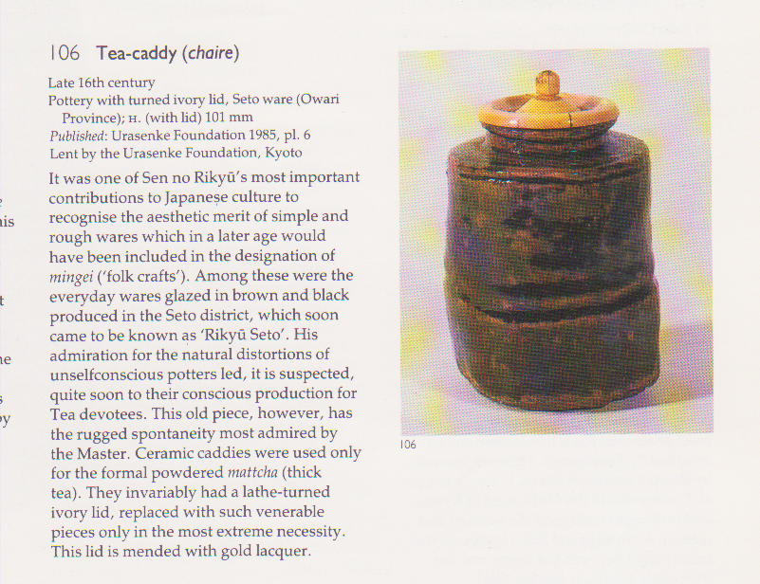

*Sabi* aesthetics of the aged and worn were promoted and valued by the samurai and Zen followers. This is shown through the use of worn and historically significant ceramics used in the tea ceremony.

**CONCLUSION**

Zen Buddhism and samurai society combined and formed an aesthetic quality that was uniquely Japanese. At first, Zen, with its Chinese origins based on compassion, does not seem to have similarities to the Japanese warrior elite. However, while samurai were known for their violence, the samurai ideal was perpetuated with strict principles and morals that reflected Zen belief. Zen was a peaceful sect of Buddhism, but acknowledged many forms of meditation including military art as a way to reach enlightenment. Through these initial similarities, samurai adopted Zen as their religion, making Zen the prolific belief in Japan. This connection developed and strengthened the Zen and samurai concepts of discipline and self realization. As time passed, Zen and samurai influence on society became intertwined; their shared values of honorable poverty and aged and worn objects formed new aesthetic qualities that shaped the apex of Japanese culture. By elevating these concepts through the ceremonial *Chanoyu*, the culmination of samurai and Zen belief became synonymous for Japanese value. The Japanese Tea Ceremony shows this connection between Zen and samurai society through the aesthetics used in tea bowls.

# Bibliography

Agency for Cultural Affairs. *Japanese Religion: A Survey.* Tokyo and New York: Kodansha International, 1972.

Collcutt, Martin. *Five Mountains: The Rinzai Zen Monastic Institution in Medieval Japan.* Cambridge, MA: Harvard University Press, 1981.

Davis, Winston. *Japanese Religion and Society: Paradigms of Structure and Change.* New York: State University of New York Press, 1992.

Ellwood, Robert S., and Richard Pilgrim. *Japanese Religion: a cultural perspective.* Englewood Cliffs, NJ: Prentice-Hall, Inc., 1985.

George J. Tanabe, Jr., ed. *Religions of Japan in Practice.* Princeton, NJ: Princeton University Press, 1999.

Heine, Steven, and Dale S. Wright, . *The Kòan: Texts and Contexts in Zen Buddhism.* Oxford, New York: Oxford University Press, 2000.

Hume, Nancy G. *Japanese Aesthetics and Culture: A Reader.* Albany, New York: State University of New York, 1995.

Jiro Harada, Lit. D. *A Glimpse of Japanese Ideals: Lectures on Japanese Art and Culture.* Tokyo, Japan: Kokusai Bunka shinkokai, 1937.

King, Winston L. *Zen and the Way of the Sword: Arming the Samurai Psyche.* New York, Oxford: Oxford University Press, 1993.

M.E.Guth, Christine. *Art, Tea, and Industry: Massuda Takashi and the Mitsui Circle.* Princeton, NJ: Princeton University Press, 1993.

Mason, Penelope. *History of Japanese Art.* New York: Harry N. Abrams, Inc., 1993.

Nukariya, Kaiten. *The Religion of the Samurai: A study of Zen Philosophy and Discipline in China and Japan.* New Jersey: Rowman& Littlefield, 1973.

Smith, Laurence, Victor Harris, and Timothy Clark. *Japanese Art: Masterpieces in the British Museum.* New York: Oxford University press, 1990.

Stephen Addiss, Stanley Lombardo, and Judith Roitman, ed. *Zen Sourcebook: Traditional Documents from China, Korea, and Japan.* Indianapolis/Cambridge: Hackett Publishing Company, Inc., 2008.

Suzuki, Daisetz T. *Zen and Japanese Culture.* Princeton, NJ: Princeton University Press, 1959.

Turnbull, S.R. *The Samurai: A military History.* New York : MacMillanPublishing Co., INC., 1977.

ILLSTRATIONS:

1. *Song dynasty, 960-1279; Jian ware*. CULTURAL CHINA, 2007-2010

<http://arts.cultural-china.com/en/31Arts4401.html>

1. *Tenmoku Ware* Mason, Penelope. *History of Japanese Art.* New York: Harry N. Abrams, Inc., 1993, Pg 210.
2. *Teabowl named Hòrinji****,*** Smith, Laurence, Victor Harris, and Timothy Clark. *Japanese Art: Masterpieces in the British Museum.* New York: Oxford University press, 1990, pg 120.
3. *Tea Bowl, called Mount Fuji****.*** Mason, Penelope. *History of Japanese Art.* New York: Harry N. Abrams, Inc., 1993, pg 241.
4. *Teabowl, named Mine no Momiji.* Met Museum special exhibit, December 2003 to January 2004. http://www.metmuseum.org/special/Oribe/ceramics_pop_04_024.asp
5. *Tea Caddy,* Smith, Laurence, Victor Harris, and Timothy Clark. *Japanese Art: Masterpieces in the British Museum.* New York: Oxford University press, 1990, pg 119.

1. Ellwood, Robert S. and Richard Pilgrim. *Japanese Religion: a cultural perspective.* New Jersey: Prentic-Hall, Inc., 1985, pg. 14
2. Suzuki, Daisetz T. *Zen and Japanese Culture.* New York: Princeton University Press, 1959; pg 10.
3. Turnbull, S.R. *The Samurai: a Military History.* New York: Macmillan Publishing Co., INC., 1977, pg 126
4. Turnbull, pg 148.
5. Ellwood, pg 95.
6. Collcut, Martin. *Five Mountains: The Rinzai Monastic Institution in Medieval Japan.* Cambridge: council on East Asian Studies, Harvard University;1981,pg 19.
7. Collcut, pg 27
8. Ellwood, 54
9. King, Winston L. *Zen and the Way of the Sword: Arming the Samurai Psyche.* New York, Oxford: Oxford University Press, 1993, pg 28.
10. Collcut, Martin. Pg 20-21.
11. Collcut, pg 26.
12. “ And when, in 1214, priest Eisai administered a bowl of tea to Shogun Sanetomo who was suffering from the excessive use of sake, its beneficial effect was so marked that the Shogun greatly encouraged the use of tea among his vassals.” Harada, Jiro. *A Glimpse of Japanese Ideals: Lectures on Japanese Art and Culture.*Tokyo: Kokusai Bunka Shinkokai, 1937, pg 197.
13. Collcut,, pg 9.
14. Suzuki, pg 22.
15. Mason, Penelope. *History of Japanese Art.* New York: Harry N Abrams, Inc., Publishers,1993; pg 209-210.
16. records show that a reverence for simple, unassuming pottery, as used by Chinese Zen monks, was by the thirteenth century an important part of these exercises and that they were indeed already being copied at the Seto kilns. Here lies the origin of the essentially Japanese Cha-no-yu, where, however important the various arts brought together by the occasion, it is the ceramics which take the greatest precedence. ( It was partly from the canons of Tea Taste ceramics, indeed, that the whole modern studio pottery movement was derived, with its overwhelming influence in Europe and North America in the twentieth century.)” Smith, Lawrence, Victor Harris and Timothy Clark. *Japanese Art: Masterpieces in the British Museum.* New York: Oxford University Press, 1990, pg 117.
17. Turnbull, pg 127, quoting from Yamamoto, 1977c, pp 66-67
18. Smith, pg 117.
19. Nukariya, Kaiten. *The Religion of the Samurai: A study of Zen Philosophy and Discipline in China and Japan.* New Jersey: Rowman & Littlefield; 1973. Pg xiv
20. Suzuki, pg 5.
21. Nukariya, pg 36.
22. Smith, pg 117.
23. King, pg 234.
24. Suzuki, pg 146.
25. Mason, pg 238-239.
26. Ellwood, pg 40
27. Smith, 120
28. Ellwood, pg 107
29. Okakura, Kakuzo. *The Ideals of the East with special referent to the art of Japan.* New York, Tokyo, Osaka & London:ICG Muse, Inc., 2000; pg 172-173.
30. King, Winston L. *Zen and the Way of the Sword: Arming the Samurai Psyche.* New York; Oxford University Press, 1993, pg 12.
31. Smith, pg 182.
32. Suzuki, pg 28.
33. Turnbull, pg 146
34. Harada, pg 198.
35. Suzuki, 273.
36. M.E.Guth, Christine. *Art, Tea, and Industry: Massuda Takashi and the Mitsui Circle.* Princeton, NJ: Princeton University Press, 1993, pg 55.
37. Mason, pg 241.
38. Davis, Winston. *Japanese Religion and Society: Paradigms of Structure and Change.* NY: State University of New York Press, 1992; 158.
39. Suzuki, 23
40. Suzuki, 254
41. Hume, Nancy G. *Japanese Aesthetics and Culture: A Reader.* Albany, New York: State University of New York, 1995, pg 272.
42. Smith, pg 128
43. Suzuki, pg257
44. Smith, 118. HOWEVER, Suzuki describes sabi meaning loneliness or solitude, pg 24.
45. Suzuki, 285
46. Nukariya, pg 35
47. Suzuki, pg 338.